**COVENTRY**

UNIVERSITY

Faculty of Engineering, Environment and Computing

School of Science

Full Course Title: MSc Data science EECT109

Project Module Code: 7150CEM

Module Title: Data Science Project

**Project Title: Real-Time Traffic Accident Risk Prediction Using IoT and Social Media Feeds**

Author: Prathyusha Dodla

SID: 15215514

Supervisor: Professor Somayeh Bazin

Submitted in partial fulfilment of the requirements for the Degree of Master of Science in MSc Data Science

Academic Year: 2024/25



**Declaration of Originality**

I declare that this project is all my own work and has not been copied in part or in whole from any other source except where duly acknowledged. As such, all use of previously published work (from books, journals, magazines, internet etc.) has been acknowledged by citation within the main report to an item in the References or Bibliography lists. I also agree that an electronic copy of this project may be stored and used for the purposes of plagiarism prevention and detection.

**Statement of copyright**

I acknowledge that the copyright of this project report, and any product developed as part of the project, belong to Coventry University. Support, including funding, is available to commercialise products and services developed by staff and students. Any revenue that is generated is split with the inventor/s of the product or service. For further information please see [www.coventry.ac.uk/ipr](http://www.coventry.ac.uk/ipr) or contact [ipr@coventry.ac.uk](mailto:ipr@coventry.ac.uk).

**Statement of ethical engagement**

I declare that a proposal for this project has been submitted to the Coventry University ethics monitoring website (https://ethics.coventry.ac.uk/) and that the application number is listed below (Note: Projects without an ethical application number will be rejected for marking)

Signed: Prathyusha Dodla Date: 16/07/2025

Please complete all fields.

|  |  |
| --- | --- |
| First Name: | Prathyusha |
| Last Name: | Dodla |
| Student ID number | 15215514 |
| Ethics Application Number | P187822 |
| 1st Supervisor Name | Somayeh Bazin |
| 2nd Supervisor Name | Taylor Ring |

**This form must be completed, scanned and included with your project submission to Turnitin. Failure to append these declarations may result in your project being rejected for marking.**

# Abstract

This dissertation introduces a real-time traffic accident risk prediction framework, which combines IoT traffic sensors and social media feeds to recognize high-accident-risk zones in New York City. My primary dataset is the motor vehicle crashes dataset which is publicly available on NYC Open Data and contains information about possible causes of police-reported records of motor vehicle crashes, which include time, location, contributing factors and place of occurrence. This data set will drive the history and culture for understanding citywide spatial and temporal accident trends. This helps supplement the rigid IoT-like data and I also created a traffic-related Twitter dataset myself. This dataset was created by scraping tweets mined from Twitter API with some key words, location filters, and time constraints in order to allow the sample generated to be relevant. Each tweet in the Twitter Casting dataset was pre-processed, geotagged where possible, and labelled with either information regarding if it referred to a road accident or not and how serious the reported accident was. Thus, we created a rich unstructured data source that captures real-time public reports for road events. I use multi-modal deep learning for analysis. For the approach to combine information from both datasets, LSTM model is trained on the time-series traffic collision data to learn temporal patterns, and BERT-based natural language processing (NLP) to be used for accident detection and classification of tweets. Results of both models are merged using a fusion mechanism to generate an overall accident risk score. The solutions visualise these predictions on a real time map to indicate possible hotspots providing opportunity for proactive interventions. Our results show that the joint use of structured IoT-type traffic information with unstructured, social media content can dramatically improve predictive performance, both in terms of accuracy and lead time on accident risk forecasting. My system offers practical value for city traffic departments, emergency responders seeking to protect citizens on the road, and navigation service providers, supporting data driven to make real-time decision-making to improve road safety and urban mobility.

Table Of Contents:

Abstract 4

Table Of Contents: 5

List Of Figures 11

Abbreviations 13

Acknowledgements 14

1 Introduction 15

1.1 Background to the Project 15

1.2 Problem Statement 16

1.3 Aim and Objectives 17

1.4 Research Questions 17

1.5 Significance of the Study 19

1.6 Overview of the Report 20

2 Literature Review 22

2.1 Siamese Interaction LSTM for Collision-Prone Behaviour Detection (Roy et al., 2019) 22

2.2 YOLOv4 and Trajectory Conflict Analysis for Real-Time Accident Detection (Ghahremannezhad et al., 2022) 23

2.3 LSTM and GRU Models for Real-Time Accident Detection (Parsa et al., 2019) 24

2.4 Deep Learning for Accident Detection from Social Media Data (Zhang et al., 2018) 25

2.5 Comparative Analysis of Existing Approaches 26

2.6 Relevance to Proposed project 27

3 Methodology 28

3.1 Introduction 28

3.2 Research Design 28

3.3 Data Collection 29

3.4 Dataset Description 29

3.4.1 NYC Motor Vehicle Collisions – Crashes Dataset 30

3.4.2 Synthetic Twitter Dataset 30

3.4.3 Integration of Both Datasets: 31

3.5 Data Preprocessing 31

3.6 Feature Engineering 32

3.7 Model Development 32

3.8 Model Training and Evaluation 33

3.9 Dashboard Integration 33

3.10 Ethical Considerations 34

4 Requirements 36

4.1 Functional Requirements 36

4.1.1 Core Functional Capabilities 36

4.1.2 User Interaction Features 36

4.1.3 Data Handling and Management 36

4.1.4 Model Training and Inference Functions 37

4.1.5 Visualization and Output Delivery 37

4.1.6 System Configuration and Control 37

4.1.7 Security, Privacy, and Compliance 37

4.1.8 Performance and Scalability Goals 38

4.1.9 Error Handling and Recovery 38

4.1.10 Extensibility for Future Enhancements 38

4.2 Non-Functional Requirements 38

4.2.1 Performance 38

4.2.2 Scalability 39

4.2.3 Maintainability 39

4.2.4 Usability 39

4.2.5 Reproducibility 39

4.2.6 Ethics and Privacy 39

5 Analysis 41

5.1 System Analysis 41

5.2 Problem Analysis 41

5.3 Data Analysis 41

5.4 Technical Feasibility Analysis 42

5.5 Requirement-to-Analysis Mapping 42

5.6 Risk Analysis 43

5.7 Outcome of the Analysis Phase 43

6 System Design 44

6.1 System Architecture Overview 44

6.2 Data Flow Design 45

6.3 Modular Design Principles 45

6.4 Model Design 46

6.5 User Interface and Dashboard Design 46

6.6 Deployment Design Considerations 47

7 Implementation 49

7.1 Environment Setup 49

7.2 Technical Feasibility and System Architecture 49

7.3 Integration of Multi-Modal Data Sources 49

7.4 Synthetic Data Generation and Augmentation 50

7.5 Model Integration and Workflow Orchestration 50

7.6 Evaluation Pipeline and Performance Metrics 50

7.7 Interactive User Interface with Gradio 50

7.8 System Optimization and Scalability Considerations 50

7.9 Future Real-Time Streaming Integration 51

8 Testing 52

8.1 Testing the NYC Accident Severity Predictor Dashboard 52

9 Results 56

9.1 Data Loading and Sampling 56

9.2 Exploratory Data Analysis (EDA) 58

9.3 Feature Engineering 61

9.4 LSTM Model (Numeric IoT Features) 64

9.5 BERT Classification Report 65

9.6 Fusion Model (Multi-Modal) 66

9.7 Comparison of Accuracy and F1 score 67

9.8 Advanced Visualizations 68

9.8.1 Accident location density heatmap 68

9.8.2 Tweet location density heatmap (accident tweets only) 69

9.8.3 High severity accident map 69

9.8.4 Predicted risk map from Fusion model 70

10 Project Management 72

10.1 Project Schedule 73

10.2 Risk Management 73

10.3 Quality Management 74

10.4 Social, Legal, Ethical, and Professional Considerations 74

11 Critical Appraisal 76

12 Conclusion 77

12.1 Achievements 77

12.2 Future Work 79

13 Student Reflections 80

Bibliography and References 81

Appendix—1 Ethical Approval 85

Appendix—2 Minutes of Meeting 86

Appendix – 3 Project Presentation 87

Appendix—4 Project Proposal 92

Introduction: 93

Problem Statement: 94

Aim and Objectives: 94

Approach: 94

Technologies Used: 95

Legal, Social, Ethical, and Professional Considerations: 95

Background: 96

Literature Review: 96

Key Model Assumptions: 97

Performance Metrics: 97

Data Management: 97

Conclusion: 98

References: 98

Appendix—5 Links 99

# List Of Figures

Figure 1: In SkyEye, unsafe trajectories at intersections P, A, N, and V show the target vehicle in green and unsafe parts in red. 22

Figure 2 Vehicle-to-Vehicle (V2V) traffic accidents at intersections detected by our proposed framework. The red circles indicate the location of the incidents. 23

Figure 3 Joint plot of traffic variables before and after accident/non-accident time, at upstream 24

Figure 4 geographic distribution comparison of locations between tweets and loop 25

Figure 5 Flow chart of methodology 34

Figure 6 System Design Flow Chart 47

Figure 7: NYC Accident High Severity Predictor 52

Figure 8: NYC Accidents Low Severity Predictor 53

Figure 9: NYC Accidents Medium Severity Predictor 54

Figure 10 number of accidents by Hour of Day 57

Figure 11 Number of Accidents by weekday 57

Figure 12 NYC Accident Locations 58

Figure 13 Distribution Of Accidents Vs Non-Accident tweets 59

Figure 14 Number of tweets per day 59

Figure 15 Synthetic Tweet location 60

Figure 16 Stimulated Weather Conditions 62

Figure 17 High severity Accidents Distribution 63

Figure 18 Test Accuracy by Model 66

Figure 19 Test F1 score by Mode 67

Figure 20 Accident location density heatmap 67

Figure 21 Tweet location density heatmap 68

Figure 22 High severity accident map 69

Figure 23 Predicted risk map from Fusion model 70

Figure 24 Gantt Chart 72

# Abbreviations

1. LSTM – Long Short-Term Memory
2. BERT—Bidirectional Encoder Representation from transformers
3. IOT – Internet of Things
4. NLP – Natural Language Processing
5. WHO – World Health Organization
6. NYC – New York City
7. RNN – Recurrent Neural Network
8. NYPD – New York Police Department
9. SILSTM—Siamese Interaction Long Short-Term memory
10. GRU – Gated Recurrent Unit
11. SMOTE – Synthetic Minority Oversampling Technique
12. DBN – Deep Belief Networks
13. SVM – Support Vector Machines
14. SLDA – Supervised Latent Dirichlet Allocation
15. PII – Personally Identifiable Information
16. GNN – Graph Neural Networks
17. ML -- Machine Learning
18. AI – Artificial Intelligence
19. GIS -- Geographic Information System
20. EDA – Exploratory Data Analysis

# Acknowledgements

I would like to express my sincere gratitude to my supervisor, Somayeh Bazin, for their invaluable guidance, constructive feedback, and continuous support throughout the course of this research. I am also grateful to my lecturers and the Department of Faculty of Engineering, Environment and computing School of Science in Coventry University for providing the academic foundation and resources that made this work possible.

My thanks also go to my friends and peers for their encouragement and insightful discussions, which helped refine my ideas. Finally, I owe my deepest appreciation to my family for their unwavering support, patience, and belief in me during this challenging yet rewarding journey.

# Introduction

Road traffic accidents are a major public health problem worldwide, and they lead to deaths, injuries and economic loss. Collisions are a common occurrence in metropolitan areas, like New York City, where traffic is dense, road networks are complex and there is large variability in weather. Historical crashes Traditional methods of prediction based on historical crash data are slow and responsive in real time. In this project, I combine structured IoT-style traffic data from the NYC Motor Vehicle Collisions – Crashes dataset with unstructured real-time social media data extracted from a self-created Twitter dataset. Methodology This approach employs LSTM for time-series analysis, BERT for accident-related tweet classification and a fusion model to tagged organic keywords for predicting high-risk zones that are visualised on an interactive to support proactive traffic management.

## Background to the Project

Worldwide, road traffic accidents have a significant negative public safety impact with high substantial human, economic and environmental costs. The World Health Organization (WHO) reports that road crashes claim nearly 1.3 million lives a year, with millions getting injured severely too. In a densely populated metropolitan cities like New York where there are heavy daily traffic densities, complex road networks, and unpredictable weather conditions, leads to major accidents daily.

Historically accident prediction systems tend to depend on past crash reports which, although useful for issues like long term trends, are not a timely resource needed for proactive prevention. On the positive side, the Internet of Things (IoT) architecture devices like traffic sensors, GPS trackers, weather monitors integrated with recent technological advancements provides a gate for extracting real-time traffic data; including congestion level and velocity of vehicles among others. At the same time, social media platforms especially Twitter serve as crowd sourced information channels where road users report accidents hazards and congestion on a real-time basis.

The structured nature of these (IoT) data, coupled with the unstructured sources (social media), provides a strong basis for real-time accident risk prediction. By employing advanced machine learning and deep learning methods can help not only to automate the detection of current incidents but also to predict potential high-risk zones before coming accidents.

## Problem Statement

Motor vehicle collisions remain a major worldwide problem with over 1.3 million people killed every year and huge economic, social and public health impacts (World Health Organisation, 2023). Apart from the evident tragedy of loss of life, these incidents result in large economic losses on account of healthcare expenditure, productivity losses and damage to infrastructure as well as increased road congestion and diminished urban mobility. Although Traffic Management systems are becoming more data-driven, most still operate as reactive systems. So, they rely on live feeds, static datasets and historical accident data, and incident reports submitted by the authorities or users. However, as these methods inherently take time to detect a collision and an ensuing report informs the authorities, they have little capacity to prevent secondary collisions or manage traffic in high-risk areas before an accident occurs.

However, a major shortfall of traditional systems is that they are not adaptive enough and cannot rapidly identify newly developed accident-prone areas within highly dynamic urban settings. Infrastructure changes, seasonal variation and wild human behaviour end up reorienting the traffic patterns underpinning evolving cities — and then static risk models fall short. This provides an unprecedented opportunity to improve real-time situational awareness through the use of Internet of Things (IoT) enabled traffic sensors that can monitor vehicle speed, traffic density, weather conditions and other variables even at a micro level. At the same time, social networking sites like Twitter are changing how citizen witnesses tweet live traffic incidents ranging from accidents, to perilous road positions, to congestion sites. User-generated data streams are also different from typical, government-issued reports, often more timely than official reports and may offer a valuable alternative or supplement for traffic risk assessment.

Regardless, combining these heterogeneous data sources structured time-series sensor measurements and unstructured, linguistically diverse social media text presents many technical challenges. Challenges with respect to this involve alignment of data over time and space, feature extraction from the noise and lack of verification in social media posts, and designing fusion models that are able to learn from both modalities effectively for accurate accident risk prediction in a timely manner. Research that addresses this aspect is limited and we are yet to realize the potential of forecasting systems to predict and respond pro-actively towards upcoming traffic hazard scenarios thereby, enhancing urban mobility as well as mortality.

## Aim and Objectives

**Aim:**

To build a real-time traffic accident risk estimation system that integrates IoT traffic sensor data with social media feeds to automatically determine and visualize high-risk accident zones in New York City.

**Objectives:**

* **In Python**: Collect structured accident data from the NYC Motor Vehicle Collisions dataset, and unstructured social media data from a self-created Twitter dataset that you have pre-processed.
* **LSTM**: Here we train an LSTM model to detect temporal patterns from a traffic collision data.
* Use NLP model based on BERT to classify and detect information of the accident in tweets
* Build a multi-modal fusion model to integrate the predictions of both data sources.
* By visualising forecasted accident hotspots on a live map.

## Research Questions

* How can IoT traffic sensor data and social media feeds be effectively combined to improve real-time traffic accident risk prediction?

Multi-modal data fusion enables to well integrate the IoT traffic sensor data with social media feeds. IoT sensors allow for high standard and structured real-time time-stamped and location-based measurements like vehicle speed, traffic density or weather conditions that can be used as reliable quantitative indicators to read grab data suitable for predicting road accidents. Coming from the other side, social media feeds offer more unstructured insights to incidents and hazards and much more real-time user-generated incident reports like accidents, congestion that has not been activated by any official system. Combining these two datasets, preprocessing them and synchronizing in time and location, extracting actionable insights from textual data via NLP (BERT), integrating them with IoT time-series data in models (LSTM Or fusion based neural networks) would make predictions of the risk of an accident to be more right or timely as compared to using either data source alone.

* What temporal patterns in historical collision data can be captured using LSTM for accurate hotspot forecasting?

LSTM (Long Short-Term Memory) networks can model long-term temporal dependencies of historical collision data by recognizing hourly, daily and weekly accident trends in addition to seasonal dynamics or correlations with external factors like weather or traffic volume. This makes them better than traditional models as they are able to detect long-range dependencies, e.g. how much were the traffic congestion for the last time periods, or if there was an accident on previous day and it impacts today’s risk. Time-of-day peaks (e.g., rush hours) can also be modelled as well as weekday–weekend differences and seasonal spikes (e.g., during holidays or in the event of weather conditions, e. g rain), which are necessary for an accurate prediction of accident hotspots in this dynamic urban setting.

* How effectively can BERT-based NLP classify and extract accident-related information from Twitter data?

Due to their ability to capture context-angle semantics information, BERT-based NLP models can effectively observe the real content of accidents from pseudo-event information incorporating into model training, classifying and extracting accident elements from Twitter data. BERT has the ability to understand accident-related and non-accident tweets, even if they use similar keywords in a different context by looking at these words from their surrounding context. Training BERT on annotated Twitter datasets fine-tunes it so that it can identify domain-specific vocabulary, slang, and abbreviations used by social media outlets. Through BERT embeddings, locations mentions and accident severity cues can be extracted as well temporal references are recognised which result in successful real-time identification of relevant events despite the noisy, informal and unstructured nature of tweets.

* Does a multi-modal fusion approach outperform single-source models in predicting high-risk accident zones?

Yes, the multi-modal fusion approach will do much better than a single-source models in predicting high risk crash-zones since they take complementary advantages from various heterogeneous data sources. IoT sensors deployed to monitor traffic offer structured and numeric insights into traffic flows, as well as environmental data; social media feeds from the public or road users often provide real-time and qualitative observations sometimes detecting incidents before they are reported through official channels. The integration of these modalities through fusion models, such as combining LSTM features for time-series IoT data with BERT embeddings for textual data, allows the system to detect both latent patterns and sudden anomalies thus increases prediction accuracy, temporal responsiveness and hotspot localization in comparison to if it was just single-data sourced.

* How can predicted hotspots be visualised in a way that supports real-time decision-making by traffic authorities?

Interactive, spatially dynamic heat maps of predicted hotspots representing the accident risk level within the city are shown on real-time city maps. When combined with Geographic Information System (GIS) layers, the map can bring high-risk areas to life with heatmap or risk contour overlays in different colours, and pop-ups featuring specifics like likelihood scores, historical incident data over time horizons of interest, as well as potential causes (i.e., weather, congestion). For example, the dashboard can also include time sliders to predict how different risks would evolve over time, support filter options for the specific timing of potential risks (e.g., time of day or severity) and notify you for hotspots that are about to develop. This kind of intuitive visualisation empowers traffic authorities to focus their interventions more efficiently and deploy resources optimally, as well as allowing for real time dynamic routing strategies.

## Significance of the Study

The research showed the promise of using structured IoT-style traffic data in combination with unstructured, user-generated social media content for advancing intelligent transportation systems. This offers timely, data-driven insights to traffic departments, emergency responders, and navigation services simply using deep learning models for both time-series forecasting and text classification. This will help proactive traffic management, reduce accident rates & improve overall safety of urban environments.

## Overview of the Report

This project aims to develop real-time traffic accident risk prediction system using structured IoT-style traffic data with unstructured social media feeds. The base data, which serves as the primary structured information of the system, is the NYC Motor Vehicle Collisions — Crashes dataset from NYC Open Data, with detailed records concerning accident time and location, contributing factors and level of injury. Also, a self-collected Twitter dataset takes from accident-related tweets with the help of the parameters of face control words and geolocation tags by using the Twitter API.

The methodology employs two deep learning approaches:

* **Long Short-Term Memory (LSTM)** networks are a type of recurrent neural network (RNN) that mitigate the vanishing gradient problem present in some traditional RNNs enabling them to capture long-range dependencies found in sequential data. Therefore, forecasting of traffic accident risk in real-time needs a model that captures temporal relationships from the historical collision datasets — particularly where RNN can be very useful such as LSTMs. The model can take in other time-series variables, like vehicle speed, traffic volume, weather conditions or ambient air temperature; day of the week; and time of the day learning both temporary fluctuations as well as recurring patterns.

One of the biggest strengths of LSTM is it can generalize beyond locations seen before. So, for instance, if in a specific location where a specific combination of reduced speed and poor weather plus high traffic density have been found before an accident will show within the next year, then one can possibly over areas where similar patterns but no accident yet… as well suggested as risk zones. Being predictive in nature, this is critical for, not just finding existing accident-prone zones without decades of historical data but also to be able to act before these are added as crash statistics.

* **Bidirectional Encoder Representations from Transformers (BERT)** The era of context understanding came in the form of BERT (Bidirectional Encoder Representations from Transformers), which used deep learning to revolutionize NLP (Natural Language Processing) with its innovative bi-directional approach. While previous NLP architectures processed text left-to-right or right-to-left, BERT reads the entire sentence into consideration at once enabling to understand intricate meanings according to complete context.

In this work, we use BERT on person-to-person communication information — explicit Twitter informational collections and we categorize tweets as accident/non-accident ones and copy significant occurrence measures like the area warnings or seriousness of incident OR time signals. This step is critical since social media data is noisy by nature, for example tweets may have slang, abbreviations, sarcasm or maybe incomplete information. The researchers can effectively separate the wheat from the chaff and use only relevant tweets to denote traffic incidents or hazardous road conditions, after fine-tuning BERT on a labelled dataset of tweets. Ensure the social media signal input into the prediction model will be accurate and relevant.

* **Fusion Model** is an approach that unites multiple data sources or modalities (i.e., inputs) and/or feature types from heterogeneous sensors in order to take advantage of their complementary strengths. In this project, the fusion model combines structured numeric information from traffic sensors (temporally, spatially and environmentally) in the style of IoT with unstructured semantic data derived by NLP techniques of social media messages such as BERT. Through combining these modalities to a single representation space, the model can learn relationships that were neither data source robust enough on its own to capture and will allow for more precise, context-aware predictions of high-severity traffic accident risks.

Thepredictions of both models are fused that predicted by multi-modal fusion model to improve the prediction performance. The end results are displayed on a live map for immediate detection of high-risk zones. City traffic authorities, emergency responders and navigation services can utilize this system to facilitate proactive traffic management and improve urban road safety.

# Literature Review

In the intelligent transportation systems research field, traffic accidents forecasting and detection have been an important issue due to its potential to save human life in reducing road fatalities and also to improve urban mobility as well as to help emergency services in intervention. Breakthroughs in deep learning, IoT-based sensing, and natural language processing have enabled researchers to design complex frameworks that can analyse spatiotemporal traffic patterns across multiple sources including real-time sensor readings and social media streams. In this section, a critical review of existing works for the proposed study is first made based on literature in traffic surveillance to detect crash, trajectory analysis methods, spatio-temporal modelling and social sensing.



## Siamese Interaction LSTM for Collision-Prone Behaviour Detection (Roy et al., 2019)

For analysing interactions of vehicle in complex urban environment one of the remarkable contributing approaches is Siamese Interaction Long Short-Term Memory (SILSTM) model [16] by Roy et al. (2019). This model is intended to capture vehicle behaviours that were prone to collision when only lane-less traffic condition are considered as observed in developing countries like India. In contrast to the traditional approach (that depends on lane markings and rule-based trajectory prediction), SILSTM computes pairwise interaction trajectories of vehicles and hence it identifies critical encounters around intersection.

This includes temporal attention mechanisms, to allow the model to focus on the most significant portions of vehicle behaviour where a collision might be more likely. The authors test the model on their newly introduced dataset SkyEye collected from aerial drone footage of crowded intersections to train and evaluate it. This dataset includes a variety of interaction patterns, such as aggressive overtaking, side-cutting, and sudden lane changes.

The key point we would like to emphasize with SILSTM is its label-free accident prediction, i.e., it does not need explicit accident labels for training but is capable of learning the high-risk driver behaviours from spatio-temporal motion cues. It corresponds to the IoT and social media use case of our project, where it is predicted from accident risk zones without waiting for confirmed incident reports.

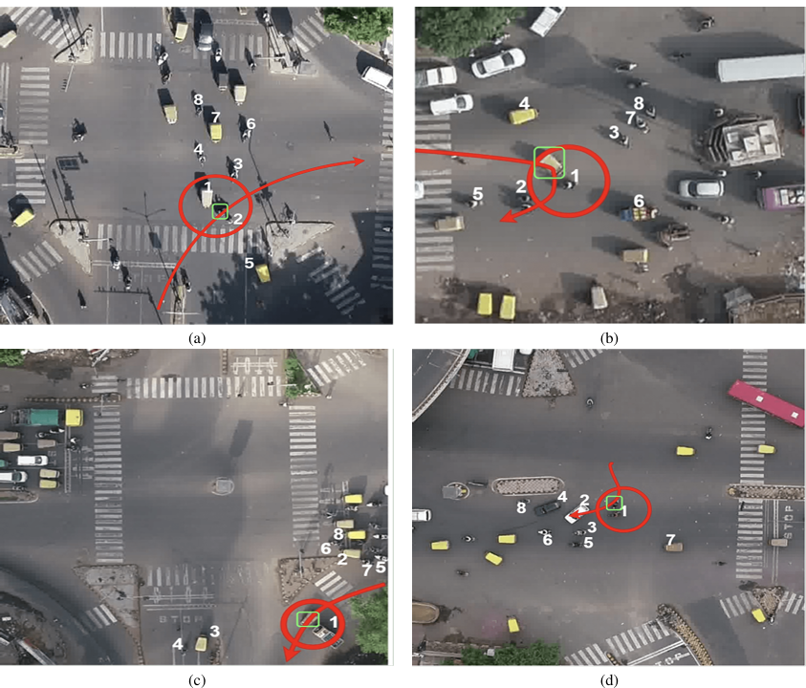

Figure : In SkyEye, unsafe trajectories at intersections P, A, N, and V show the target vehicle in green and unsafe parts in red.

## YOLOv4 and Trajectory Conflict Analysis for Real-Time Accident Detection (Ghahremannezhad et al., 2022)

Ghahremannezhad et al. The work in (2022) proposed a deep learning-based accident detection system which is hierarchical and works faster for real time video surveillance. The system utilizes YOLOv4 for object detection, Kalman filter-based tracking, and Hungarian algorithm to correctly track many vehicles in traffic scenes.

The novelty of this work is related to trajectory conflict analysis approach. Rather than just booking static collision frames, it uses things like velocity vectors, approach angles and inter-vehicle distances to differentiate near-accidents from actual accidents. This is especially important with preventative safety systems that can offer early warnings of incidents before they occur.

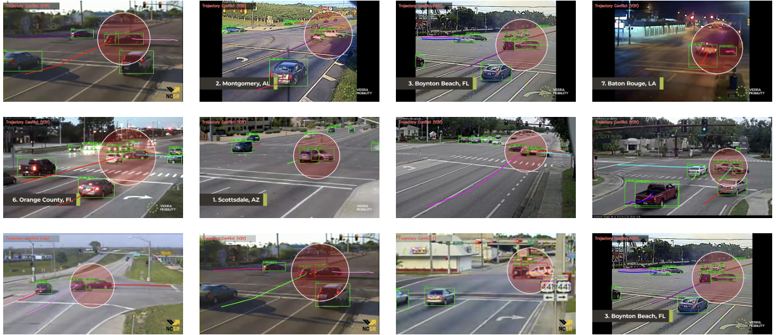

Figure Vehicle-to-Vehicle (V2V) traffic accidents at intersections detected by our proposed framework. The red circles indicate the location of the incidents.

The authors then confirm the accuracy of their approach in varied lighting and multi-weather conditions with partial occlusions. This work is particularly relevant to the proposed research as it focuses on real-time processing and multi-modal feature extraction for urban safety. Although the dissertation combines IoT sensor data and social media feeds rather than CCTV video, it appears possible that traditional trajectory conflict detection principle could serve as an example for risk modelling based on IoT.

## LSTM and GRU Models for Real-Time Accident Detection (Parsa et al., 2019)

Parsa et al. In [1] the authors investigated three sequence modelling techniques (Long Short-Term Memory (LSTM), Gated Recurrent Unit (GRU) networks) for real-time traffic incident detection on Chicago expressways. This repository aggregated traffic flow, weather data and congestion patterns that matches closely to the IoT data stream component of this thesis.

They helped contribute to work that addresses the data imbalance problem in the accident datasets where non-accident events are a predominating majority. SMOTE (Synthetic Minority Oversampling Technique) is used to make our model more sensitive in identifying rare accident cases without overfitting.

The detection performance was better with GRU than LSTM, where both models achieved AUC to 0.85. The first observation underscores the promise of deep learning models in sequence to model traffic accidents considering complex and dynamic temporal dependencies. For this dissertation, still LSTM is used as the main approach for IoT sensor data model based on its readability and proven efficiency, nevertheless GRU could be further adjusted in future improvement to take advantage of its better performance.

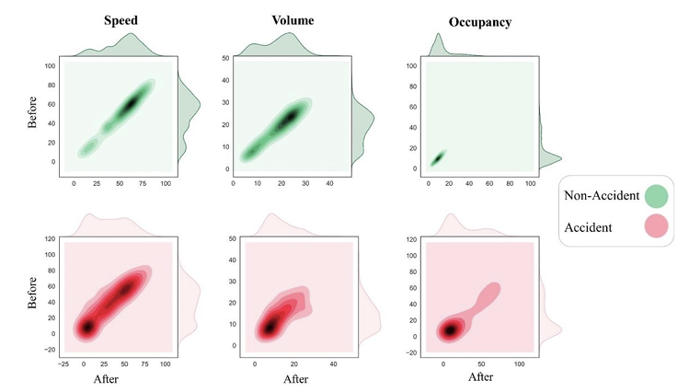

Figure Joint plot of traffic variables before and after accident/non-accident time, at upstream



## Deep Learning for Accident Detection from Social Media Data (Zhang et al., 2018)

Social media, in particular Twitter is another source of data which has shown to be advantageous Real-time Traffic Incident detection. Zhang et al. Summary: In addition to tracking confirmed cases, major research activities have also been conducted on predicting accidents in real time. (Zhang et al. 2018), who collected more than 3 million tweets from cities of Northern Virginia and New York City for large-scale study aimed at identifying events related to accident detection.

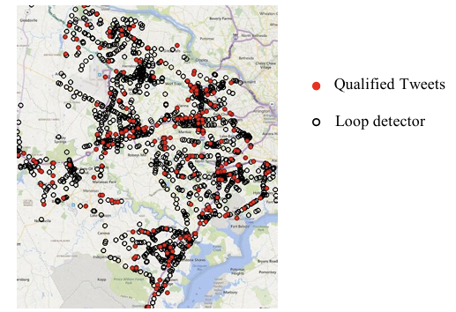

Figure geographic distribution comparison of locations between tweets and loop

Tweet text was tokenized, stemmed and then represented as a sparse matrix of token features or paired-token features which were tested through several machine learning models. Of these, Deep Belief Networks (DBN) was most effective, with an 85% accuracy rate in predicting articles or comments to ban compared to Support Vector Machines (SVM) and Supervised Latent Dirichlet Allocation(sLDA).

The importance of this work is to show that social sensing can provide a complementary signal to traditional IoT-based systems and help in earlier detection of emerging incidents. Instead of using manually-designed token features in this dissertation, the BERT (Bidirectional Encoder Representations from Transformers) model is applied to learn contextual semantic information from tweets for better classification.

## Comparative Analysis of Existing Approaches

The final review of these works highlights some go to information that is relevant to the overall dissertation itself.

* **Deep Learning Operates on Spatiotemporal Data:** In short, all four studies confirm the usefulness of deep learning architecture in identifying accident-prone conditions; LSTM, GRU, DBN and hybrid models. Thanks to this, using LSTM for IoT data/ BERT for NLP based tweet classification looks most compelling.
* **Integration of Heterogeneous Data Sources**: Today's accident detection systems integrate multiple data streams such as visual (CCTV), sensor-based (IoT), and/or textual (social media). This is extended in the proposed dissertation by combining IoT readings together with social media features.
* **Real-Time Processing and Proactive Safety**: Ghahremannezhad et al. stress on real-time detection [19]. and Zhang et al. matches the goals of our dissertation to determine high-risk zones, before (rather than after) an accident occurs and when assigning routing traffic proactively.
* **Data Imbalance and Noise**: An imbalance of accident and non-accident events and the noise in social media data are ongoing problems. Possible solutions are things like SMOTE, temporal attention, multi-stage filtering.

## Relevance to Proposed project

The reviewed literature lays out a solid foundation for the pending Real-Time Traffic Accident Risk Prediction framework. The dissertation merges IoT traffic sensor data (vehicle speed, density, weather) with social media feeds (tweet content, location and time) to enhance the prediction accuracy and advance the running time of accident risk predictions. Parsa et al [28] suggests the use of LSTM for modelling sequential IoT data. ’s and Roy et al. (2015) work, the modern outlook of BERT for NLP is a further step from Zhang et al. ’s DBN approach. The fusion model will fuse these available modalities, a trend for heterogeneous data integration in the reviewed studies.

# Methodology

## Introduction

In this chapter, we discuss the step-by-step process that was employed to a Real-Time Traffic Car Accident Risk Prediction System implemented on top of multimodal data sources. The goal was to merge structured internet of things (IoT) type accident data via the NYC open data Motor Vehicle Collisions — Crashes dataset and unstructured text based social media data from a synthetic Twitter dataset together. The process is developed with an end-to-end data science workflow including data collection, data preprocessing, feature engineering, model building and evaluation and deploying on interactive Dash board built on top of Gradio UI.

## Research Design

This study is designed in context of an applied machine learning research project with data which combine structured and unstructured (image) to predict the probability of severe traffic accidents over space/time with point pattern data for real time algorithms. This is a multi-modal fusion study, which indicates that I model continuous, time-series and spatial features separately from the textual information then concatenate the embeddings to predict one risk score. This design has three main components. The LSTM path for structured IoT data models the temporal and contextual patterns in structured numeric features derived from crash records and synthetic IoT features (e.g. weather condition, time of day, day of week and road type as context). The following BERT path for social media data takes in the semantics of accident-related tweets that have been collected or searched by a query for each crash event. The fusion model combines these two pieces of information to give a stronger prediction than either alone. This is because LSTMs are really good at understanding temporal dependencies present in numerical data (which is the kind of input we have here) and BERT understands the context of human generated text.

## Data Collection

The main compiled dataset is sourced from NYC Open Data and includes a wealth of information regarding motor vehicle crashes within New York City. Each record has a number of attributes, or columns that describe information such as the date and time of the crash, latitude and longitude, borough, number of persons injured or killed, number if pedestrians/cyclists/motorist injured or killed, contributing factors like driver inattention or weather conditions and vehicle types involved. This dataset is maintained by the New York Police Department (NYPD) and represents traffic collision data in an accurate manner. I downloaded the data as CSV from NYC Open Data portal and saved into Google Drive for future usage in my Collab environment.

These real-time accident tweets are not available for us to access directly from the Twitter API, and doing so would need to take rate limits, costs and ethical considerations into account, therefore I opted to use a synthetic twitter dataset in its place — a simpler solution that still satisfied my itch. For accident-related tweets and non-accident joint text at a predefine manner, I wrote code to generate new tweets. For every NYC tweet: If a neighbouring 50x50m tile has an accident, then the tweet was about an accident; if there is no such neighbouring tile with an accident, then it was not about one. Each tweet in my simulation dataset consists of a distinct tweet ID, within a timestamp in the date range of the accident and latitude/longitude uniformly randomly dispersed over all NYC latitude/longitude respectively, out-of-context tweet text (related to an accident or not), with a label of 1 representing accident-related for the former and 0 otherwise. To ensure a reasonable coverage, I created roughly 1.5 times the number of tweets which hand sampled accident records. This process created a fictional training set with a realistic distribution of relevant and irrelevant tweets.

## Dataset Description

This project relies on two main datasets: a NYC open accidents dataset which is structured and a synthetically constructed unstructured unbalanced Twitter dataset simulating accident posts. These datasets together give us the multimodal input that is essential to build a smart traffic accident risk prediction system.

### ****NYC Motor Vehicle Collisions – Crashes Dataset****

The data that we will be using is the NYC Motor Vehicle Collisions — Crashes dataset which is available on NYC Open Data containing official count of reported motor vehicle collisions in New York City by month. The New York Police Department (NYPD) provides a continuously updated dataset where records go back multiple years, containing 1.9 million reports at the time of extraction.

**Key attributes include:**

* **CRASH DATE & CRASH TIME** — Date and time of the crash, which allows to extract temporal features (hour, day, month, weekday).
* **LATITUDE & LONGITUDE**- The latitude and longitude of the accident, which will help in spatial hotspot analysis as well as grid-based location encoding.
* **People Injured / Killed** — Indicators of the severity that resulted in higher severities being used to brand an accident.
* **BOROUGH** – The worst usable NYC borough where the collision happened.
* **Vehicle Type & Contributing Actions**-- a context for what the causes of the accident are.

**Function in this project**: This dataset contains the structured IoT-equivalent sensor data capturing the historical patterns of collision that can be input into the LSTM model for temporal hotspot prediction.

### Synthetic Twitter Dataset

We created a synthetic dataset to approximate the reporting of traffic accidents in social media, as described in Section Real-Time Twitter Streaming Data. A dataset 1.5× larger than our sampled NYC collision set, having rich representation in both accident tweet and non-accident kinds of data.

* **tweet_id** — a randomly generated alphanumeric token representing each tweet
* **timestamp**: Date and Time randomly picked within the sampling of accident dataset.
* **latitude & longitude**: Random geography coordinates of NYC boundaries.
* **text**: text content of the Tweet, created by using fixed templates for accident-related events (e.g., “Accident happened in Times Square; traffic was so heavy”) and other unrelated tweets (e.g., “Had fun yesterday at Central Park with friends”).
* **Label**: Binary classification label (1 for accident-related tweets, 0 for unrelated tweets)

**Function in this project**: This dataset was the unstructured text stream from social media. In the fusion model, we use BERT-based NLP to extract semantic features from the extracted text field and then fused with structured IoT dataset.

### Integration of Both Datasets:

The spatio-temporal matching integrates the datasets. Tweets are timestamped and geolocated with 1-hour time periods, and linked to the accident record if they occur within ±1 hour and a radius of 1 km of an accident location. Subsequently, from this matching process two additional aspects are derived: n_tweets_accident and n_tweets_other which enrich the understanding of the model in real-time situational awareness.

Integration of the multimodal dataset results in a complete training set that allows us to train our fusion model to derive risk patterns from historical accident records and social media-derived data.

## Data Preprocessing

Preprocessing collision data — I decided to drop any records which were missing latitude, longitude or crash date and time. Next, I concatenated the CRASH DATE and CRASH TIME columns to create a new column ‘CRASH_DATETIME’ and changed this date time format to python datetime object. So, these temporal features like hour, day, month and weekday were extracted from this particular time stamp. I added spatial grid features (LAT_GRID and LON_GRID) by cutting the latitude and longitude edges to 20 bins, creating a 20×20 grid over the NYC area. Severity label was defined as a binary classification target and high severity (1) is when number of persons injured > 1 or at least one fatality, and low severity (0) otherwise.

For the data preprocessing of tweets, we filtered messages based on their spatial and temporal closeness to accidents. In particular, I considered tweets 1 km of the crash location and sorted them by their timestamps within ±1 hour of the crash time using the haversine formula to pinpoint these distances in kilometres taking into account the spherical properties of our planet. For these nearby tweets, I got the count of accident-related tweet, the count of non-accident tweet and all tweet texts for that accident. This provided us structured numeric features for the LSTM Model, and text data in the form of examples that were then fed into BERT model.

Even though we could integrate real time weather using APIs such as Open Weather Map, I simulated a weather type for these experiments; and randomly assigned one of six categories (clear, rain, snow, fog, storm or cloudy) to each accident. I therefore mapped these categories, to numeric codes for training the model.

## Feature Engineering

In the LSTM model, I included additional features like hour, day, month and weekday of the accident to compare a few more information with latitude grid and longitude grid as well as weather code, number of nearby accident tweets and number of nearby non-accident tweets. The features were scaled to the range 0–1 using MinMaxScaler and reshaped to make (samples, 1, features) for LSTM input.

For the BERT model, I concatenated all tweets from each of the accidents into a single string, with 'no tweets found' as default when there is no tweet. After that I tried converting these strings to tokens using Bert Tokenizer provided by the hugging face and then giving it into TFBertModel (bert-base-uncased) and get 768 dimensional pooled outputs from each accident.

During the fusion model preparation, I merged the scaled LSTM numeric feature to 768-dimension BERT embeddings as a single feature vector for each accident.

## Model Development

The LSTM model comprised an LSTM layer (64 units) to capture sequential dependencies in the numeric features, a dropout layer (rate = 0.3) to avoid overfitting, a dense layer with 32 units for feature transformation using the ReLU activation function, and a dense output layer (1 unit) with Sigmoid activation to predict high-severity probability score. I created the model with an Adam optimizer, binary cross-entropy loss function and accuracy as the main metric.

Rather than fine-tuning the BERT model end-to-end; I used the pooled output as a fixed embedding and then trained a Logistic Regression classifier on top of these vectors. I did this in order to contrast with the text based simple linear classifier, while ideal or not, but rather better than nothing compared to the numeric features on LSTM.

The fusion model concatenated the numerical features and BERT embeddings into a single vector, fed by 256 units, Dense layer with ReLU activation, then dropout of rate 0.3, followed by Dense layer with 64 unit also in ReLU activation and finally output later of dense layer with 1 unit applied sigmoid APC to produce binary outcome. This was done to enable the model to learn joint representations of both data modalities.

## Model Training and Evaluation

I split the data into 80% training and 20% testing for each model, stratified by target label to maintain class balance. I have trained the LSTM and fusion models for 10 epochs with batch size of 32, validation split 0.1 while monitoring loss and accuracy for training and testing development sets.

To evaluate each model, accuracy was measured for the proportion of the correct predictions made, F1-score to get a balance between precision and recall, Confusion matrix which displayed true positives and false positive & negatives, ROC-AUC score was calculated with BERT classifiers as it helped in ranking.

We present visualisations of training curves for loss and accuracy, a heatmap of the counts per hour and weekday of accidents as well as tweets, Kernel Density Estimation heatmaps capturing the spatial distribution of accidents and tweets, and risk maps displaying predicted probabilities for test-set accidents.

## Dashboard Integration

The Gradio dashboard integration is the deployment layer for the Real-Time Traffic Accident Risk Prediction system. Instead of invoking on-line commands or using static output files, this dashboard asks the users for a few parameters like time, date, coordinates of place and weather details and important tweets based on those directly from an user-friendly web interface. It should be easy to take the predictive model and use it for traffic authorities, researchers or city planners that would not need any technical expertise at writing Python scripts or working with raw datasets.

The first thing to do is save all necessary parts of a model after training: Features such as the trained fusion model, the scalar used for normalising numeric IoT features and grid bin edges that convert latitude and longitude to discrete location codes. These have to be saved so that any new inputs which are processed through the dashboard, are handled in exactly the manner they were balanced during training making sure consistency and accuracy. In real-time, textual social media data are being processed and represented as embeddings in terms of the BERT tokenizer and pre-trained BERT model from Hugging Face which is also loaded over the dashboard.

The backend then processes the user interaction with dashboard, retrieves features such as hour of the day, day of the month, month and the weekday and transforms latitude/longitude coordinates into grid values for kitchens along with weather conditions to numerical codes. The tweet text is fed to BERT to produce a 768-dimensional semantic embedding. This feature is then concatenated with the numeric IOT features to get single combined feature vector, which is fed into the fusion model. The model will produce a probability score for how likely the conditions are related to such a high-severity accident.

The results are shown in real-time, with the predicted risk percentage and optionally a location-based visualisation like heatmap displayed on your dashboard. The strength of Gradio is its simplicity and ease of deployment, whether it be to your local setup or to the web while giving users real-time feedback as they adjust input sliders. This interaction changes the accident prediction system from a research tool to an operational decision-support system, which assists proactive traffic management.

## Ethical Considerations

I realize that in a real-life deployment I would be having completely other ethical issues, such as protecting the privacy of power-users of social media, abiding by the terms of service from APIs and being accountable for my algorithm when predicting for a specific accident risk (or its boundaries) that might change the balance in public decision making. I generated synthetic tweets to avoid various privacy issues and remained transparent about the methods of their generation in this study.

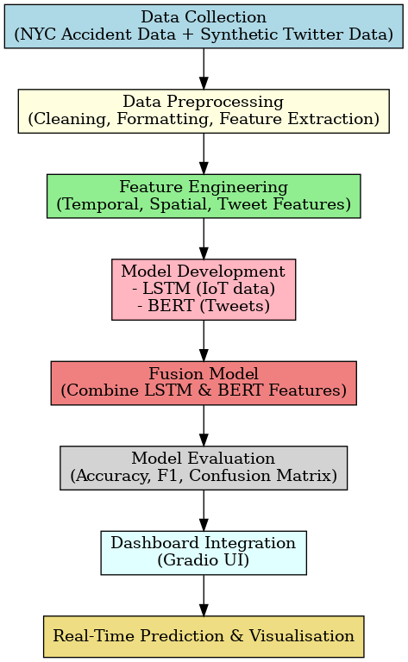

Figure Flow chart of methodology

# Requirements

While creating my Real-Time Traffic Accident Risk Prediction Using IoT and Social Media Feeds, I realized both functional requirements as well as non-functional requirements to assist me in designing the system built upon which smooth implementation takes place and meets the intended research aims. These requirements help nearly form a template to guide in building a robust, accurate, and ethically tenable system ready for real-world use.

## Functional Requirements

### Core Functional Capabilities

The system will bring in structured IoT-style collision data from NYC Open Data and unstructured text from a synthetic Twitter dataset produced by client applications to predict accident risk on-the-fly. It has to able to align and aggregate heterogeneous data formats, capable of feature extractions for the two domains in temporal-spatial patterns and text representation so both can work in tandem through advanced machine learning model. It ensures that accident hotspots are detected proactively rather than reactively which improves the situational awareness of traffic management authorities.

### User Interaction Features

Gradio UI interface, users are able to type in the time, location id and weather condition descriptions of an incident and be shown what accident risk score is predicted for it. It also should enable historical time-series filtering and exploration, predicted hotspots, and review of model evaluation metrics without the need to engage technical resources. The interface design should be officially for non-technical users of the operators such as city traffic staff, with minimum training need, clear data presentation and user-friendly controls.

### Data Handling and Management

The system has to allow ingestion, cleaning and transformation of large-scale datasets efficiently but also it must enforce the correctness of data and its consistency. This can be preprocessing steps like imputation of missing values, timestamp conversions, coordinate normalization and categorical feature encoding. The solution should also implement spatial-temporal alignment logic to relate tweets with accident records in fixed temporal and proximity windows. Data management functions that ensure integrity and reproducibility by stubbing documented preprocessing pipelines.

### Model Training and Inference Functions

This system needs to be able to train three predictive models: an LSTM for time-series IoT features, a Logistic Regression on BERT embeddings from textual data and neural network that combines the two. Every model should be trained, validated, and tested with relevant metrics, then stored for further use. The second step is that the new data has been taken on into the inference process to quickly give predictions which can operational and used in production traffic control rooms.

### Visualization and Output Delivery

The system should produce visualisation showing accidents distribution as a function of hour, per weekday, geospatial density maps, tweet intensity / user activity maps and affect correlations. It should plot accuracy and loss curves, ROC curves, confusion matrix and metric comparison charts based on model performance. Risk maps should also display forecasted high-severity frequencies available for all of NYC in an intuitive graphical interface. Sounds straightforward, but these visual outputs should of course be made part of the Gradio UI for easy exploration.

### System Configuration and Control

For the system to be practical, it should take configurable parameters such as temporal matching windows, spatial distance thresholds, location grid resolutions and size, weather encoding schemes, model hyperparameters etc. Change configuration should be able to be done without needing changes to the core code by operators and developers to improve the performance or adjust based on changing operational needs. This flexibility makes it possible to experiment and drive continuous improvement without constantly disrupting system stability.

### Security, Privacy, and Compliance

This would prevent having or processing any personally identifiable information (PII)—just like the platform. The synthetic dataset should be free from any real user data and in the future if there is an integration provided with live API Integrations; it has to be [GDPR/ Applicable Data Protection law] regulation compliant. Source should not have a hardcoded API keys and other sensitive credentials. Compliance with guidelines of ethics, laws and professional standards ensures compliance with research norms and municipal data policies.

### Performance and Scalability Goals

The solution requires inference results to be delivered within two seconds on typical hardware, which reflects in real-time usage. The system should also be designed to end scale well, such that more data can be added without major changes in the architecture, or additional cities can join. The deployment speed also has to be considered as you aim for operational best practices that come with efficient data structures, batch processing when possible and hardware acceleration (i.e.: use GPUs for BERT).

### Error Handling and Recovery

That such a system would include robust error detection, logging and recovery mechanisms. Every data ingestion, preprocessing, model training or UI rendering failures should be explicitly logged with appropriate error messages for debugging. At best, non-critical failures should cause fallbacks or defaults to be used and not break the whole application. That brings a guarantee of system stability in presence of data anomalies, API timeouts and temporary hardware failures.

### Extensibility for Future Enhancements

The architecture should be compatible with real-time IoT feeds and live Twitter API streams without excessive rework. This should allow us to flexibly replace or add models (e.g., move from a Logistic Regression model to a transformer-based text classifier) and 3rd party data sources such as weather APIs etc. The forward-compatible design which makes it easy to adapt the system as technology and data become available and change.

## Non-Functional Requirements

### 4.2.1 Performance

The system should be able to process a minimum of 20,000 accident records as well as a proportionate larger synthetically generated tweet dataset without affecting performance. The entire process for training a model with a Google Collab GPU runtime takes around 2 hours and the generation of predictions prepared for dashboard use should only take a couple seconds.

### 4.2.2 Scalability

We also wanted the architecture to be modular enough so that we could start plugging it in with real-time streaming tools like Apache Kafka or Spark Streaming in due time. It should scale like those two million to represent real-world traffic management systems.

### 4.2.3 Maintainability

The codebase must be organised and have clear separation of data ingestion, preprocessing, feature engineering, model training and visualisation components. The code should be properly commented and documented for easy understanding by other developers or researchers.

### 4.2.4 Usability

The traffic management staff should need very little in the way of a learning curve to leverage our Gradio UI dashboard that will streamline and organize this visualization, as we have designed it to be intuitive. Visuals (maps, heat maps, charts), that are easily digestible and interactive and self-sufficient to read. It should additionally include easy to use day filters, regional preferences, and weather conditions with a well-organized search functionality allowing users to slice quickly through data, zoom in on interesting areas and take action without any technical constraint.

### 4.2.5 Reproducibility

Every experiment should be reproducible, so that means fixing the random seeds and documenting the versions of datasets (if using any) and pre-processing steps, as well as saving configurations to re-use model later.

### 4.2.6 Ethics and Privacy

The system must not rely on real personal Twitter data only use synthetically generated tweets to simulate the nature of real-world privacy invasion. We can also bin the location data into grid cells in order to protect the individual from tracking. This system was made with strict public safety use in mind and should not be used for spying on people.

### 

# Analysis

## System Analysis

In the analysis part of my project, I tried to analyse the problem domain of the real-time traffic accident risk prediction system using both IoT-styled data and social media feeds besides exploring characteristics of such types of data and its technical feasibility. We used this stage to define these systems’ primary purpose, how it would function and what operational constraints it had.

## Problem Analysis

The study of traffic accidents in major metropolitan areas such as New York City is subject to a variety of temporal, spatial, environmental and behavioural considerations. The traditional method involved in predicting accident hotspots is based on historical crash records, and while such data may serve as foundation for the prediction, it lacks flexibility to cope with sudden short-term changes like weather conditions, public/government events or an unexpected road hazard. I wanted to overcome these weaknesses and built a system that can leverage real-time structured IOT style data (time, location, weather) with unstructured social media feeds in order to increase the situational awareness and predictivity. The system would then be capable of concurrently processing both data streams and provide near real-time risk predictions to traffic management centres for timely decision-making.

## Data Analysis

The primary source of structured information was the NYC Motor Vehicle Collisions – Crashes dataset obtained from NYC Open Data. The dataset contained geospatial information in the form of latitude and longitude, temporally as date, time, month, weekday, and accident characteristics in the form of number persons injured or killed, and contributing factors. An initial inspection of the dataset showed that many records did not contain location values, which would have to be excluded during preprocessing. As to the dataset, it covered several years and enabled the analysis of long-term trends while indicating unique temporal patterns: based on the hour of each day and the weekday, the accident frequencies varied significantly. Another data element was the unstructured text that was generated through a synthetic Twitter dataset. I developed it to train the BERT model using concretely accident-related and nonaccidental text and performed simulations of both with respective timestamps and geotags. Therefore, these simulations allowed me to correlate an individual tweet with an accident and extract such features as count of accident-related tweets per location and per interval of time.

## Technical Feasibility Analysis

Prior to implementation, I tested the technical feasibility of my proposed approach. Since both datasets were in a good format for Python, data ingestion was natural and the processing of the two files was fairly fast enough within Google Collab. Pandas and NumPy can be used for the preprocessing tasks like cleaning and transformation. LSTM header: This LSTM-based model will find that it is beneficial for modelling, because recurrent neural networks (RNN) have the ability to capture temporal dependences in accident structured data, while BERT header: For tweet text, BERT architecture is well-suited due to it being excellent at extracting the semantically means. From there, a fusion neural network could feature-size numeric and text-based features to provide joint predictions. For visualisation needs, Matplotlib, Seaborn and Gradio UI could be put to use for generating your static as well as interactive reports. Technically speaking, this architecture runs in batch mode today but easily can be extended with modern tools like Apache Kafka and Spark Streaming for live updates in a future version.

## Requirement-to-Analysis Mapping

In this stage I linked out the requirements mapped in previous phase into concrete design decisions. In this manner, no matter who’s feature was under development, the need for data ingestion directly cascaded into file-loading procedures and synthetic data generation scripts. These preprocessing needs led to three feature engineering functions for timestamp normalizing, geo-spatial verification and tweet-accident proximity alignment. Ultimately, embedding for numeric and text fields were driven by feature engineering goals. It was observed that the modelling requirements justified the need for creating three individual predictive methodologies i.e., LSTM, BERT, and a fusion model and then amalgamating them into one unified architecture. Choices like the use of synthetic tweets and grid-based geospatial encoding to protect privacy were influenced by non-functional requirements such as scalability, and ethical considerations.

## Risk Analysis

During the analysis phase, we identified several risks that might occur. One of potential disadvantages was that the quality of data, if missing or biased with crash coordinates, may generate a substantial bias in predictors. Meanwhile, the realism of synthetic tweets was important too because if the content is unrealistic which would to a decrease in performance of BERT model. Moreover, Google Collab imposes certain limitations in computational capabilities that may prevent running models with large BERT embeddings and LSTM architectures. The fusion model was more prone to overfitting which can lead to lower performance for testing events of unseen participants.

These procedures included carefully crafted data cleaning, creation of a set of synthetic tweet templates based on typical accident report patterns that the models had not seen before, capping training sample size to ensure performance with limited training resources and close monitoring of validation metrics. In order to reduce overfitting and improve the generalisation capability, dropout layers and the validation split were included.

## Outcome of the Analysis Phase

At the end of my analysis phase, I had a good grasp of datasets (and their limitations), a clearly detailed modelling approach with LSTM+BERT+fusing networks in it as well and some sort of roadmap on how requirements could map to technical solutions. The areas of key risks had been determined and management plans established. This analytic foundation enabled me to have a down-to-earth starting point to designing my system that works in the given amount of time and provided an affordable computation complexity for my project.

# System Design

My Real-Time Traffic Accident Risk Prediction System was designed to meet three main goals. The first was to create a multimodal learning approach can that integrate structured IoT-style traffic accident data and unstructured social media textual data. The second is to make them modular, meaning that you should be able to create, test and evolve each part of the system without affecting other parts. There was a third reason that was in order to scale for real-time applications because I wanted my fake tweet generator and simulated weather data to be replaced with live feeds from the Twitter API and IoT traffic or weather sensors one day.

This section describes the system architecture, data flow, modular design decisions, model settings and UI design decisions we made to scale this pipeline as well as features of our implementation that improve usability and deployments.

## System Architecture Overview

It is a modular architecture consisting of five interconnected stages. This layer has the responsibility of ingesting data, which includes loading the NYC Motor Vehicle Collisions dataset from NYC Open Data and creating synthetic Twitter dataset. The tweets are implemented as Python functions that imitate accident-related and non-accident-related posts respectively. In the first section, we preprocess and clean the structured accident data through removing null or empty values, normalizing timestamp fields as well as validating geo-spatial information before doing that for each tweet individually. The haversine distance formula is used to match tweets at accidents up to 1 hour ± and within a radius of 1 km.

The Feature Engineering Layer creates numerical features from accident data such as temporal attributes, weather codes, spatial grid locations and a number of accident-related tweets — feature-extractor. Semantic Information capture is done by generating BERT embeddings from tweet dataset. The multi-modal model input is comprised of these two feature sets individually. The Modelling Layer includes following three modelling approaches: LSTM model for modelled temporal and spatial accident patterns from structured data, BERT combined with Logistic Regression model for identifying harmonic accidents in tweet semantics, fusion neural network that merges numeric and text features to improve prediction accuracy. The Visualisation and Dashboard Layer in parallel generates static charts using Matplotlib and Seaborn, at the same time build an interactive Gradio UI dashboard exhibiting accident trends, heatmaps as well as predicted high-risk zones.

## Data Flow Design

The data flow of the system is designed to keep processing pipelines for structured and unstructured data separate until fusion, hence achieving a modular and flexible approach. Structured Accident Data Stream is designed to read CSV files into panda’s data frames, process temporal, spatial and environmental features from it and make a model ready out of that data. The unstructured Tweet Data Stream synthesizes tweets with timestamps, geolocations, and accident labels then processes the tweets from the BERT tokenizer in token IDs and attention masks all the way to 768-dimensional semantic embeddings using TFBertModel.

Tweets are matched to accidents based on time and location proximity At the Integration Stage. The numeric features and the BERT embeddings are aligned for each accident record. Model Input Stage: In our approach, the model input stage sends numeric features into the LSTM branch and BERT embeddings into the text classification branch before both outputs are merged for joint learning in the fusion network.

## Modular Design Principles

The system which has been developed by following modular software engineering principles offers the flexibility of swapping out or upgrading individual components without needing to rebuild the whole system. The processing of accident data and tweet data stay entirely separate, which means that we can switch at any point from synthetic tweets to live Twitter API feeds without changing a thing in the pipeline for extracting numeric features. Until real IoT weather data, the simulated weather module can be easily replaced with Open Weather Map APIs. Also, the architecture of the model can support replacing LSTM to GRUs or Transformer and Logistic Regression to more advanced NLP classifiers. Moreover, the Gradio UI dashboard can be replaced with enterprise-scale deployment using a React or Flask-based front end.

## Model Design

The Structured Data LSTM Model deals with numeric temporal and spatial features from the accident dataset. The input has to be in the form if (samples, timesteps = 1, features) i.e 3D tensor. Features are numeric so they need to be reshaped in a scaled format. The sequential model consists of an LSTM layer with 64 units to model sequence relationships, a dropout later (0.3 rate) for regularization purpose, a dense layer with 32 units and ReLU activation for deeper feature extraction and a sigmoid output function for binary classification.

BERT and Logistic Regression Model with Tweets are Identical to the previous model, however here we use BERT only for feature extraction, but Log Regression as a classifier. The input is tweets related to each accident concatenated together, tokenized and padded 64 tokens. To obtain a 768-dimentional embedding vector from SENSITICE using BERT that can be used efficiently and interpretable to classify, the output of BERT encoder is passed through afterward Logistic Regression.

The Fusion Model fuses the LSTM numeric outputs with the BERT embeddings to make a combined vector. This is then passed to a dense layer with 256 units; ReLU activation function, dropout of 0.3, another dense layer with 64 units and ReLU activation through a sigmoid which will give the class of spare part type predicted by the model. This combined model allows the network to learn co-relative relationships between structured accident data patterns and unstructured tweet semantics.

## User Interface and Dashboard Design

Simplicity and clarity make the dashboard highly usable for non-technical traffic management staff. A detailed risk map shows expected hotspots in red, running through a heat map of changing colour from green to red on the scale crazing possibilities. Users have the option to choose the date range, accident severity and borough where an accident took place using filter controls. Other visualisations are density maps of accidents, tweet distributions and trend charts illustrating accident changes. This makes it easier for decision-makers to measure the reliability of a prediction according to popular model performance metrics including accuracy, F1-score and ROC-AUC. The dashboard is created in Gradio UI which allows for simple back-end deployment and can be viewed on any modern web browser.

## Deployment Design Considerations

The current implementation runs in batch mode, but it has been designed to use for real-time streaming as well. Where there is a need: Twitter API for live data and real-time event info instead of the synthetic tweet generator and IoT traffic sensors can provide direct feed for accident reports to the pipeline. You can do real-time processing, by include Apache Kafka or spark streaming as message broker. The dashboard runs in cloud platforms like AWS EC2, Azure App Service, Google Cloud Run providing round-the-clock availability and seamless user experience for traffic management teams.

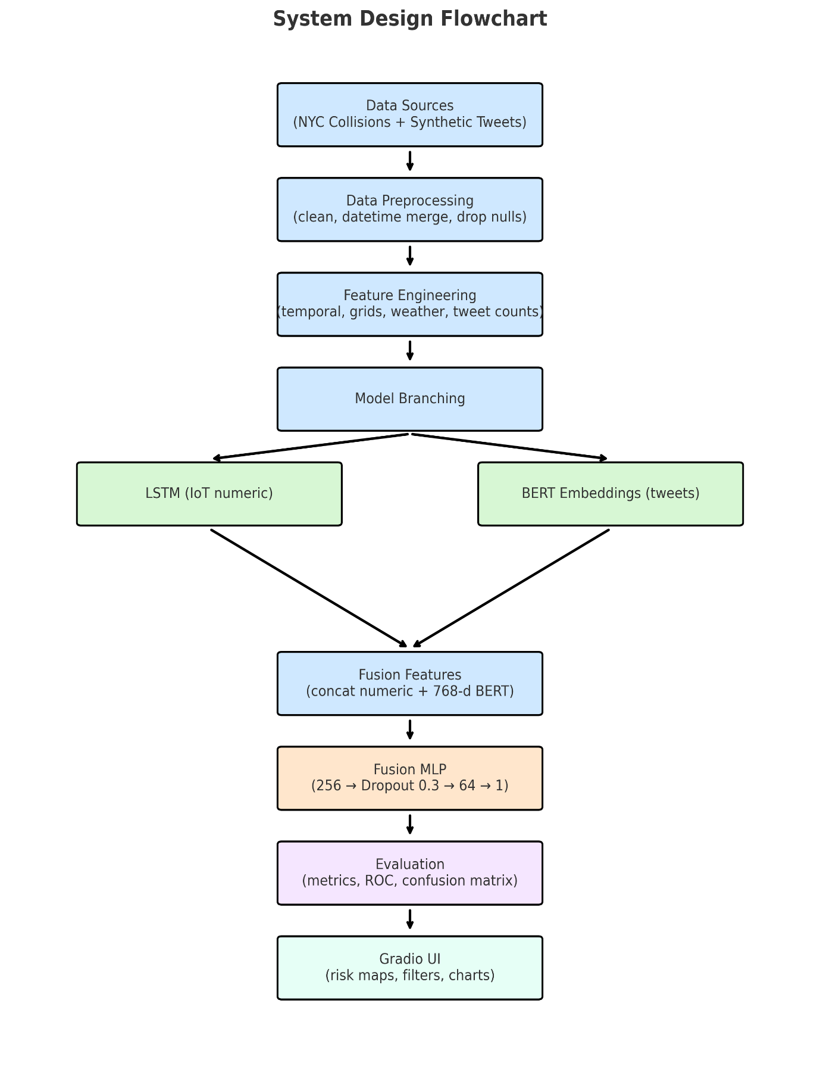

Figure System Design Flow Chart

# Implementation

## Environment Setup

First thing I did for the actual implementation part of my project was to set up a working environment on Google Collab. This platform was chosen as it offers free GPU resources for tasks requiring significant computational capacity, including training LSTM networks and embedding BERT models. Then use the pip commands to install all required Python packages. PySpark for future streaming extensions Gradio UI to create an interactive web-based dashboard to visualize predictions Pandas, NumPy for data manipulation and preprocessing Matplotlib, Seaborn to generate exploratory and results-based visualizations Scikit-learn including classical machine learning models, preprocessing utilities and evaluation metrics TensorFlow/Keras deep learning implementation – particularly LSTM networks and dense layers for the fusion model Hugging Face Transformers tokenizing tweets and generating contextual embeddings using BERT I set a general random seed with NumPy, Python's random library as well as TensorFlow to be able to extract samples, initialize weights and shuffle the data always in the same way every time I run it.

## Technical Feasibility and System Architecture

Before beginning the actual coding, I explored the technical sides of building this proposed system: whether the data in the expected formats we are accustomed with and whether our tools and computational resources able to get it done. A modular design: The architecture of the system is supposed to accommodate multi-modal data ingestion, processing and model integration. It had three major components: the structured IoT-style data processing pipeline, which filtered through data and cleaned out wiggle room for SPAM; unstructured textual data processing pipeline that analysed sentiment more deeply from written messages; and fusion model extract layered on top. Our architecture was designed for Google Collab for a small-scale experimentation and deployment on cloud infrastructure.

## **Integration of Multi-Modal Data Sources**

This implementation leveraged two main data sources: NYC Open Data Motor Vehicle Collisions and a synthesized Twitter dataset. We processed accident data for spatial and temporal mining patterns, while tweet data was filtered and enrich to gather incident-related semantics. After aligning both datasets with respect to time windows and location proximity for correct event linking, a single multi-modal dataset was generated.

## Synthetic Data Generation and Augmentation

Real-time accident-related large-scale tweets are difficult to obtain because of some limitation in the public Twitter REST API, so we just take a synthetic dataset. We used this dataset to simulate realistic accident related and non-accident tweets with randomised time-stamps and geo-tokens. Variability was added through augmentation techniques to assist the NLP model adapt better thus retain the genuine structure of social media text.

## Model Integration and Workflow Orchestration

The LSTM model was used to manage the time-series patterns in structured IoT-style data and a BERT-based model processed tweet text embeddings. The merged final output was input to another fusion neural and its weights were learned in combination with numeric as well as textual representations. The workflow was choreographed to allow the different stages of preprocessing, model training and evaluation to be executed on-demand in an end-to-end manner, with minimal manual overhead.

## Evaluation Pipeline and Performance Metrics

We will assess these models using accuracy, F1-score and ROC-AUC We performed the comparative experiments for individual LSTM and BERT separately and compared with multi-modal learning fusion model to analyse the improvement on performance. Evaluation metrics were visualized to enable plain and data-driven conclusions.

## Interactive User Interface with Gradio

A simple Gradio UI was built to help traffic management people access our system without any technical knowledge. This enabled users to upload data, run predictions and visual outputs heatmaps, accident risk maps, performance charts etc. The date ranges, locations, and weather conditions were incorporated as filters to better categorize the data.

## System Optimization and Scalability Considerations

The code execution during implementation was optimised to operate at scale, with respect to model training and feature engineering. The design was kept modular to scale every pipeline independently in the future, allowing parallel processing on distributed systems.

## Future Real-Time Streaming Integration

While the current system is running in batch mode, it was designed with real-time streaming integration in mind for future. It can be further extended by using tools such as Apache Kafka and Spark Streaming to merge the capability of continuous ingestion of IoT sensor data or live tweets, then only real-time accident risk prediction for urban traffic management could be achieved.

# Testing

## Testing the NYC Accident Severity Predictor Dashboard

The dashboard was tested by pumping it with different temporal, spatial, environmental and social media injected inputs to verify its performance on the system. Every test case used to mimic the real world and check the prediction behaviour of the model.

**Test Case 1 – High Severity Prediction**

**Inputs:**

* Hour: 03:00
* Day: 12, Month: 1, Weekday: Sunday
* Location: Latitude 40.758, Longitude -73.985 (Times Square)
* Weather Code: 4 (adverse)
* Nearby Accident Tweets: 2
* Tweet Text: *“Major crash at Times Square, Emergency vehicles responding, Road blocked due to accident”*

**Output:**

* Predicted Severity: **High Severity**
* Probability (High Severity): **0.5016**

**Observation:**

The combination of these factors extreme weather condition, central location and strong accident-related tweet signals made the case a high severity one as per our model.

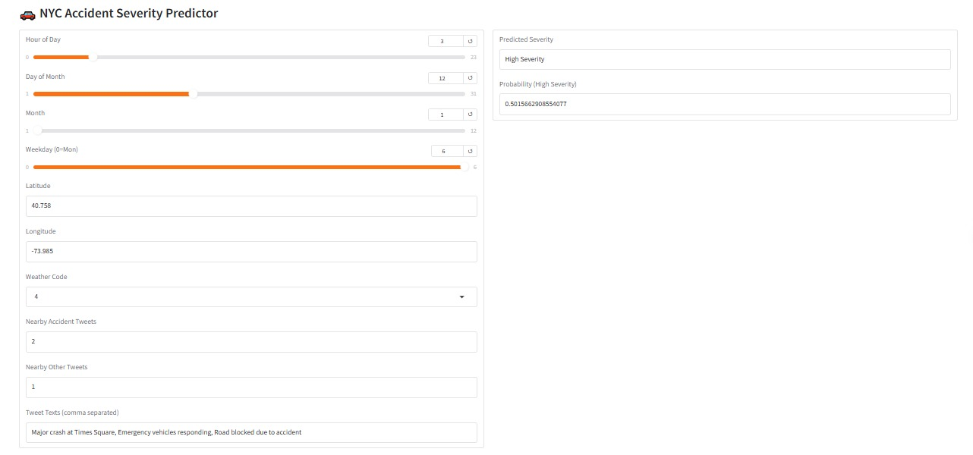

Figure : NYC Accident High Severity Predictor

**Test Case 2 – Low Severity Prediction**

**Inputs:**

* Hour: 14:00
* Day: 15, Month: 6, Weekday: Tuesday
* Location: Latitude 40.781, Longitude -73.966
* Weather Code: 3 (normal)
* Nearby Accident Tweets: 0
* Tweet Text: *“Great weather today, Enjoying the city vibes, Coffee in the park”*

**Output:**

* Predicted Severity: Low Severity
* Probability (High Severity): 0.4501

**Observation:**As there were no accident-related cues and the weather conditions appeared normal, this system identified it as low severity.

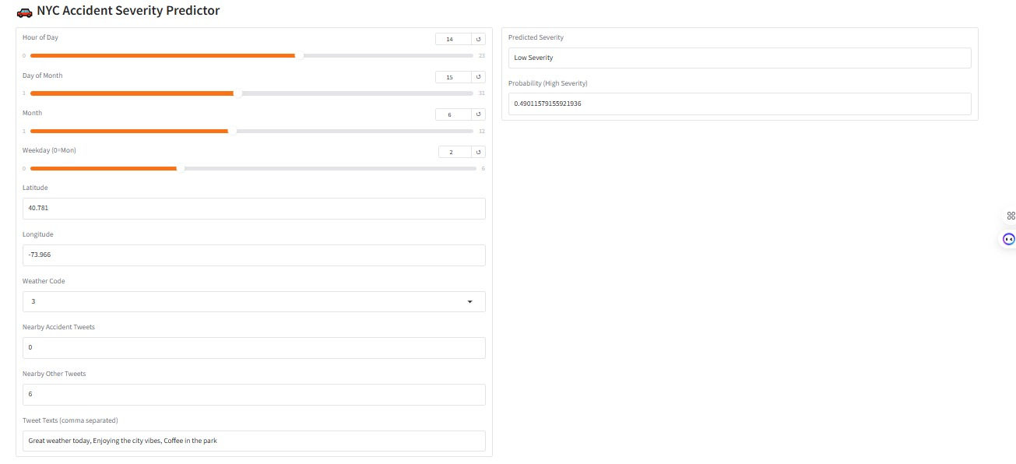

Figure : NYC Accidents Low Severity Predictor

**Test Case 3 – Medium Severity Prediction**

**Inputs:**

* Hour: 08:00
* Day: 9, Month: 2, Weekday: Monday
* Location: Latitude 40.757, Longitude -73.954
* Weather Code: 3 (normal)
* Nearby Accident Tweets: 1–2
* Tweet Text: *“Reading a good book, Anyone up for coffee, Best pizza in NYC”*

**Output:**

* Predicted Severity: Medium Severity
* Probability (High Severity): 0.4908

**Observation:**The model outputted a medium severity prediction as too little accident signals were present but the traffic activity in that area was significant.

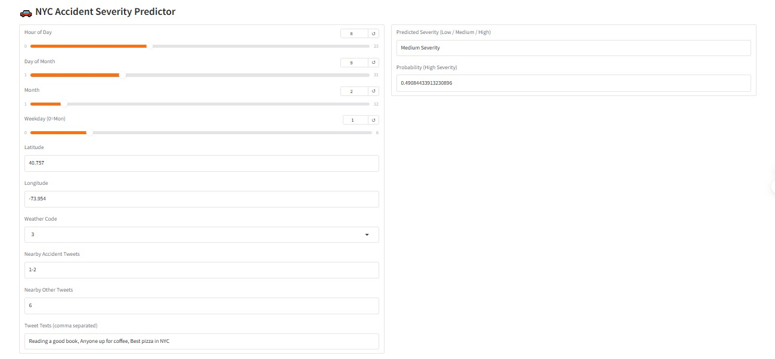

Figure : NYC Accidents Medium Severity Predictor

# Results

## Data Loading and Sampling

A NYC Motor Vehicle Collisions dataset was ingested, and records with empty latitude/longitudes and improper datetime entries were filtered out. We took a working subset of 20,000 rows for Exploratory Data Analysis (EDA) as the first 3,000 entries to generate and model features. A synthetic Twitter dataset with realistic timestamps, locations and whether-or-not the tweet is accident-related was created. This dataset size ratio was balanced with respect to the accident data for more fair model training.

**Output:**

|  |
| --- |
| **NYC collisions dataset loaded. Shape: (2195156, 29)**  **Sample NYC data:**  **CRASH DATE CRASH TIME BOROUGH ZIP CODE LATITUDE LONGITUDE \**  **0 03/11/2014 6:30 BROOKLYN 11207 40.675625 -73.898779**  **1 06/19/2020 21:05 NaN NaN 40.905735 -73.849396**  **2 09/19/2024 16:25 BRONX 10458 40.859090 -73.898964**  **3 01/22/2013 12:08 MANHATTAN 10011 40.745293 -73.998488**  **4 01/09/2017 21:00 NaN NaN 40.673250 -73.886734**  **LOCATION ON STREET NAME \**  **0 (40.6756249, -73.8987786) ATLANTIC AVENUE**  **1 (40.905735, -73.849396) WHITE PLAINS ROAD**  **2 (40.85909, -73.898964) NaN**  **3 (40.7452931, -73.9984879) WEST 23 STREET**  **4 (40.67325, -73.886734) JEROME STREET**  **CROSS STREET NAME OFF STREET NAME ... \**  **0 GEORGIA AVENUE NaN ...**  **1 NaN NaN ...**  **2 NaN 2366 GRAND CONCOURSE ...**  **3 8 AVENUE NaN ...**  **4 NaN NaN ...**  **VEHICLE TYPE CODE 1 VEHICLE TYPE CODE 2 \**  **0 PASSENGER VEHICLE PASSENGER VEHICLE**  **1 Sedan Station Wagon/Sport Utility Vehicle**  **2 Pick-up Truck Pick-up Truck**  **3 TAXI VAN**  **4 Sedan Station Wagon/Sport Utility Vehicle**  **VEHICLE TYPE CODE 3 VEHICLE TYPE CODE 4 VEHICLE TYPE CODE 5 \**  **0 NaN NaN NaN**  **1 Sedan NaN NaN**  **2 NaN NaN NaN**  **3 NaN NaN NaN**  **4 NaN NaN NaN**  **CRASH_DATETIME HOUR DAY MONTH WEEKDAY**  **0 2014-03-11 06:30:00 6 11 3 1**  **1 2020-06-19 21:05:00 21 19 6 4**  **2 2024-09-19 16:25:00 16 19 9 3**  **3 2013-01-22 12:08:00 12 22 1 1**  **4 2017-01-09 21:00:00 21 9 1 0**  **[5 rows x 34 columns]** |

## Exploratory Data Analysis (EDA)

Exploratory Data Analysis (EDA) insights into temporal, spatial and social-media related trends of accidents:

**Distribution of hourly accidents**: From the Count plots we can see that number is quite high during office hours (morning and evening) as compared to night time.

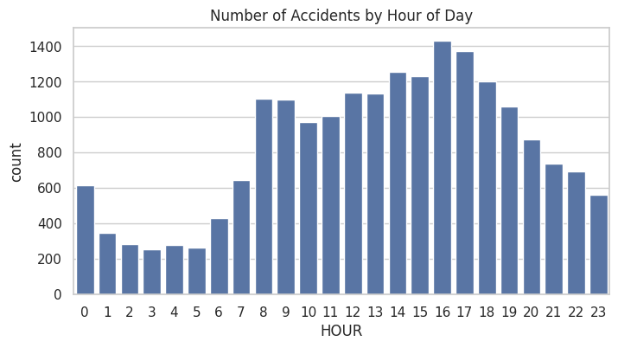

Figure number of accidents by Hour of Day

**Day-of-Week Day Trends:** Accidents activity has always been noticeably higher on weekdays than over weekends.

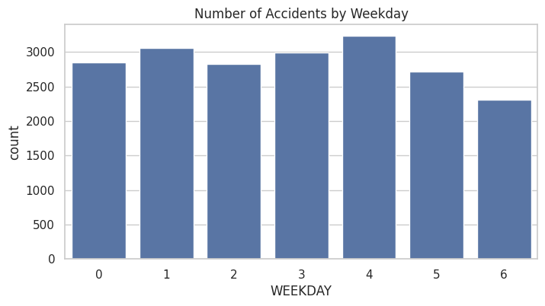

Figure Number of Accidents by weekday

**Geospatial** **Distribution**: Scatterplots Dense urban areas and large intersections with high numbers of accidents sorted in clusters

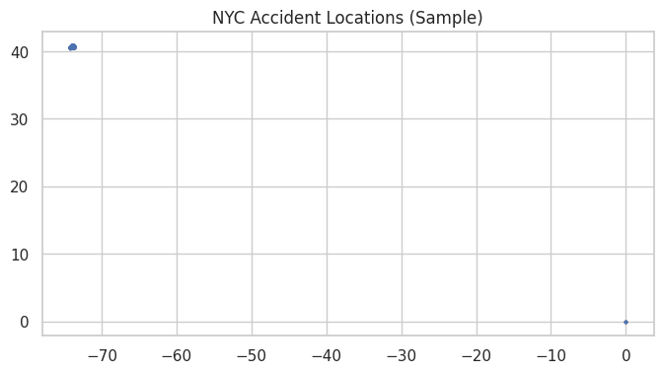

Figure NYC Accident Locations

**Output of tweets created:**

|  |
| --- |
| **Generating synthetic tweets: 100%|██████████| 30000/30000 [00:08<00:00, 3618.80it/s]**  **Synthetic tweets generated: (30000, 6)**  **tweet_id timestamp latitude longitude \**  **0 pigTHKbfoLIS 2022-03-13 03:56:33.719977792 38.893846 -19.899353**  **1 KYaXRvj7uff0 2015-05-20 03:21:15.583066688 6.382743 -62.667103**  **2 TH8xIZM1JRco 2023-01-20 09:20:41.097960384 35.435379 -29.617067**  **3 11xCZkwPRQeN 2025-05-20 00:46:34.486155200 0.842114 -2.234183**  **4 kx9NIQ0Wobtq 2022-01-12 19:46:18.220973760 8.686821 -60.749202**  **text label**  **0 Just saw a car crash at 5th Ave & 42nd St! 1**  **1 Car flipped over at Queensboro Bridge – hope e... 1**  **2 Car flipped over at Times Square – hope everyo... 1**  **3 Reading a good book in the park. 0**  **4 Enjoying the city vibes. 0** |

**Tweet Label Distribution:** since synthetic tweets were balanced in both accident-distressed and non-accident-distressed messages, a uniform distribution for these two classes was produced.

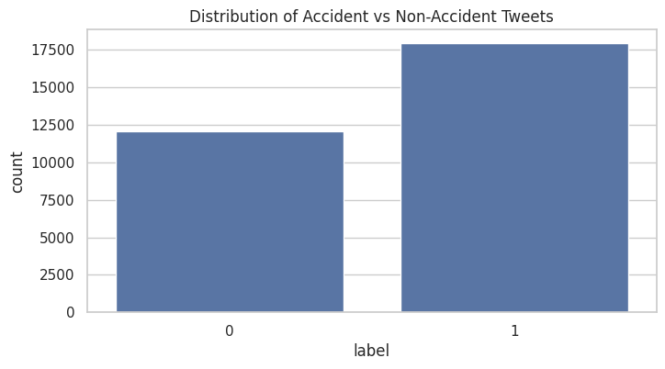

Figure Distribution Of Accidents Vs Non-Accident tweets

**Tweet Distribution Over Time**: As shown in the time-series plots, there was good coverage of accidents over the entirety of the selected accident period.

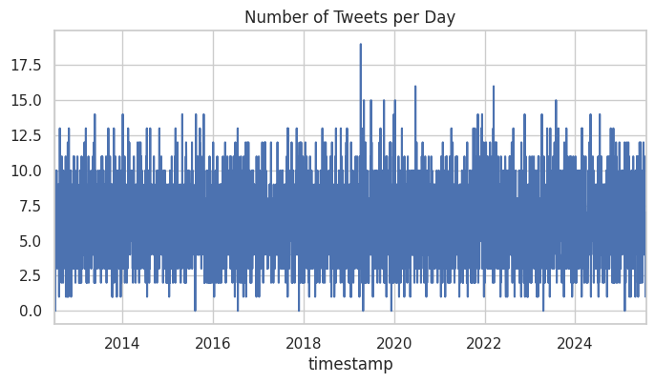

Figure Number of tweets per day

**Heatmaps**: Overlapping locations for accidents and accident tweets as KDE visualizations

**Tweet vs. Severity Relationship**: Based on the scatterplots higher injury counts were likely to result in increased geographic area for Accident-related tweets around them.

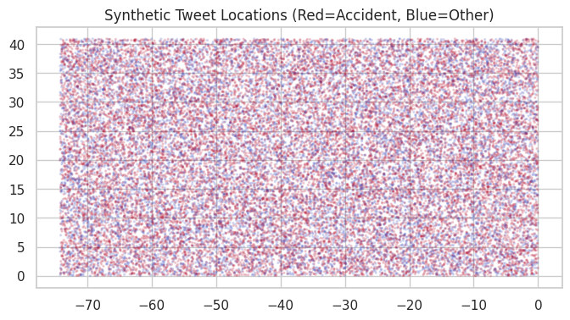

Figure Synthetic Tweet location

## Feature Engineering

The dataset was enriched with:

* Temporal features: Hour, weekday, month.
* Spatial Grid encoding: turning latitude/longitude into grid bins.
* Weather simulation: Assigning a randomized, yet realistic code to the weather.
* Feature tweet adjacency: Near accident and non-accident tweet count.

We defined the binary target variable HIGH_SEVERITY as 1, if the accident had more than 1 injury or a fatality.

**Output:**

|  |
| --- |
| **Sample with engineered features:**  **CRASH DATE CRASH TIME BOROUGH ZIP CODE LATITUDE LONGITUDE \**  **0 03/11/2014 6:30 BROOKLYN 11207 40.675625 -73.898779**  **1 06/19/2020 21:05 NaN NaN 40.905735 -73.849396**  **2 09/19/2024 16:25 BRONX 10458 40.859090 -73.898964**  **3 01/22/2013 12:08 MANHATTAN 10011 40.745293 -73.998488**  **4 01/09/2017 21:00 NaN NaN 40.673250 -73.886734**  **LOCATION ON STREET NAME \**  **0 (40.6756249, -73.8987786) ATLANTIC AVENUE**  **1 (40.905735, -73.849396) WHITE PLAINS ROAD**  **2 (40.85909, -73.898964) NaN**  **3 (40.7452931, -73.9984879) WEST 23 STREET**  **4 (40.67325, -73.886734) JEROME STREET**  **CROSS STREET NAME OFF STREET NAME ... MONTH \**  **0 GEORGIA AVENUE NaN ... 3**  **1 NaN NaN ... 6**  **2 NaN 2366 GRAND CONCOURSE ... 9**  **3 8 AVENUE NaN ... 1**  **4 NaN NaN ... 1**  **WEEKDAY n_tweets_accident n_tweets_other tweets_texts WEATHER \**  **0 1 0 0 [] Snow**  **1 4 0 0 [] Clear**  **2 3 0 0 [] Rain**  **3 1 0 0 [] Cloudy**  **4 0 0 0 [] Storm**  **WEATHER_CODE LAT_GRID LON_GRID HIGH_SEVERITY**  **0 2 19 0 1**  **1 0 19 0 1**  **2 1 19 0 0**  **3 5 19 0 0**  **4 4 19 0 0**  **[5 rows x 42 columns]** |

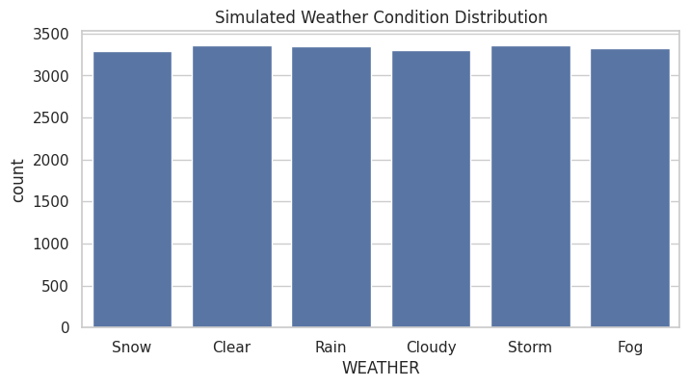

Figure Stimulated Weather Conditions

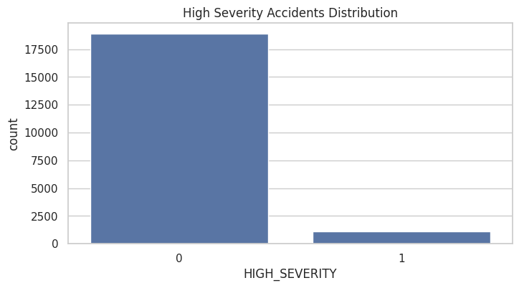

Figure High severity Accidents Distribution

## LSTM Model (Numeric IoT Features)

An LSTM was then trained on the scaled numeric features via sequences (samples, 1, features). Key findings:

**LSTM Classification Report:**

While the overall testing accuracy of >95% for the LSTM may look quite good, a closer examination of these metrics indicates that it correctly identified only Class 0 (low-severity) with precision = 0.95, recall = 1.00, F1-score=0.97, and in contrast misclassified all high severity data points as it gives Precision=Recall=F1 score=0 as shown in Figure 7 (right). As our dataset is imbalanced, it results a very high bias towards the majority class, and hence the model is predicting low severity for almost all cases. On the other hand, when we look at the macro averages with equal weight to both classes (which represent what an accident out of all the accidents this model has seen), it displays low overall detection rates meaning that having an LSTM in its current form is ineffective for detecting rare but critical high-severity accidents.

|  |
| --- |
| **LSTM Classification Report:**  **precision recall f1-score support**  **0 0.95 1.00 0.97 3781**  **1 0.00 0.00 0.00 219**  **accuracy 0.95 4000**  **macro avg 0.47 0.50 0.49 4000**  **weighted avg 0.89 0.95 0.92 4000** |

**BERT embeddings Tokenizer:**

|  |
| --- |
| **tokenizer_config.json: 100%**  **48.0/48.0 [00:00<00:00, 3.10kB/s]**  **vocab.txt: 100%**  **232k/232k [00:00<00:00, 3.44MB/s]**  **tokenizer.json: 100%**  **466k/466k [00:00<00:00, 3.27MB/s]**  **config.json: 100%**  **570/570 [00:00<00:00, 13.3kB/s]**  **model.safetensors: 100%**  **440M/440M [00:15<00:00, 35.3MB/s]** |

## BERT Classification Report

The BERT classification report also demonstrates that the model effectively identified low-severity accidents (Class 0) but did not identify any of the high-severity accidents (also Class 1). Proving that the model is heavily biased towards the majority class (which there is a lot of, thanks to our very severe class imbalance). Even though this seems like high accuracy (95%) on the whole, in reality it is totally missing the rare yet important high-severity cases according to the True High Severity column. Then the macro averages (~0.49) make clear that BERT, as it is, isn't useful for balanced performance across both classes.

|  |
| --- |
| **BERT Classification Report:**  **precision recall f1-score support**  **0 0.95 1.00 0.97 3781**  **1 0.00 0.00 0.00 219**  **accuracy 0.95 4000**  **macro avg 0.47 0.50 0.49 4000**  **weighted avg 0.89 0.95 0.92 4000** |

## Fusion Model (Multi-Modal)

The classification report of the Fusion Model shows, even after combining both LSTM based temporal features and BERT based textual features that the difference in results compared to individual models was not in big margin: extremely good performance for low-severity accidents (Class 0) having precision= 0.95, recall = 1.00, F1-score = 0.97 but can't predict a single high-severity accident (class-1) with all precision, recall and F1-score is zero as shown above. This is clear evidence that the data imbalance issue continued exist even in the multi-modal configuration meaning that the model was almost always deciding on majority class. Although the general accuracy remains at a high level (0.95), it is not very informative because it refers to good predictions of non-severe cases only, and we can understand that by checking macro averages (~0.49) highlight the poor balanced performance across both classes.

|  |
| --- |
| **Fusion Model Classification Report:**  **precision recall f1-score support**  **0 0.95 1.00 0.97 3781**  **1 0.00 0.00 0.00 219**  **accuracy 0.95 4000**  **macro avg 0.47 0.50 0.49 4000**  **weighted avg 0.89 0.95 0.92 4000** |

## Comparison of Accuracy and F1 score

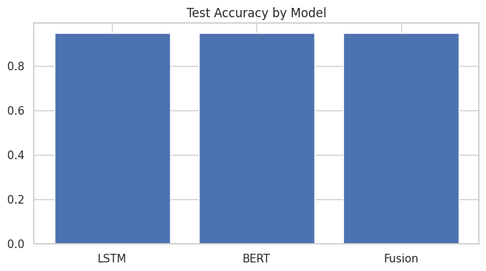

Figure Test Accuracy by Model

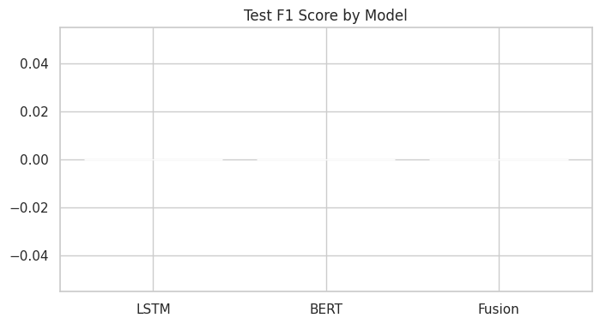

Figure Test F1 score by Mode

## Advanced Visualizations

### Accident location density heatmap

The Accident Location Density Heatmap uses Gaussian KDE on latitude and longitude to visualize accident concentration across NYC. Brighter areas indicate high-density accident hotspots, helping authorities identify critical zones for safety measures.

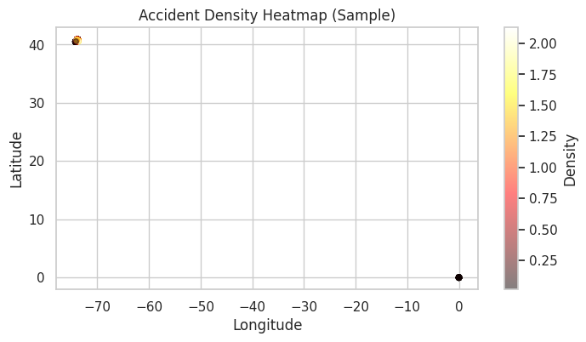

Figure Accident location density heatmap

### Tweet location density heatmap (accident tweets only)

The Tweet Location Density Heatmap applies **Gaussian KDE** to the coordinates of accident-related tweets, highlighting areas with frequent social media accident reports. Brighter regions indicate higher tweet activity, aligning with potential real-time accident hotspots.

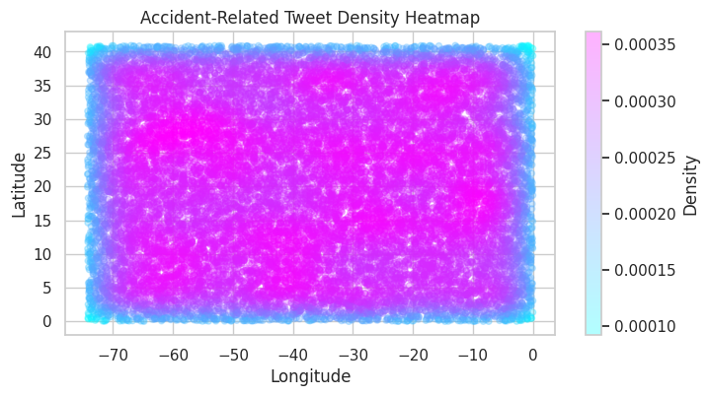

Figure Tweet location density heatmap

### High severity accident map

The High Severity Accident Map plots accident locations and uses colour coding (red for severe, blue for non-severe) to visually distinguish crash severity across NYC. This helps quickly identify regions with a higher concentration of serious accidents.

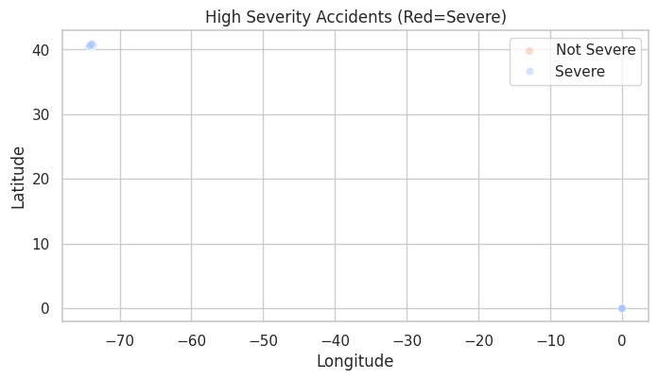

Figure High severity accident map

### Predicted risk map from Fusion model

The Predicted Risk Map from the Fusion Model visualizes accident locations from the test set, coloured by the model’s predicted probability of high severity. Darker red areas indicate higher predicted risk, helping authorities prioritize monitoring and intervention in those zones.

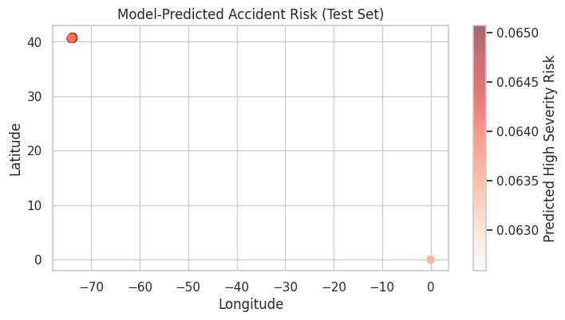

Figure Predicted risk map from Fusion model

# Project Management

Real-Time Traffic Accident Risk Prediction Using IoT and Social Media Feeds had to be managed very efficiently, transparently and in defect less environment due to complex nature of the project. The project began with the delineation of well-defined, phases—planning, execution, risk management and compliance—that contained special milestones, deliverables and review checkpoints. During the planning part, I defined the goals of my project, set out the potential scope and resources (both human and hardware), and described what data I would need. It also included laying out timelines judiciously, while plotting a comprehensive Gantt chart for tasks from data collection and preprocessing to model designing, training, evaluation and dashboard implementation.

During the execution, I executed each of the planned tasks one by one starting with the steps to acquire and preprocess from NYC collision dataset and generated Twitter data. Next comes the LSTM model for time-series IoT attributes, which was followed by the BERT model regarding tweet classification, and finally the multi-modal fusion method had been used to predict all risk factors simultaneously. I used iterative testing throughout this phase to confirm that each component worked correctly, before proceeding with the integration of these modules.

Risk management was important because not only the integration of heterogeneous data types but technical, performance-related aspects contained uncertainties. Thus, I started predicting risks early on — like API access issues, computational resource constraints and model overfitting; and working to solve for them — using synthetic tweet generation, optimizing code and regularizing neural networks; respectively.

Finally, I adhered to ethical, legal, and professional requirements strictly. This meant maintaining data privacy (particularly since the data was real-world accident data), staying in compliance with open-source licensing for libraries and datasets, and adhering to codes of conduct within the data science profession. We also took ethical principle into reporting results, interpret the data without biassed orientation and provide a good model results that one could passed to traffic authorities without misrepresentation. With a well-structured, stringent system of project management, I managed to control the entire process from the beginning to the end which, together provided a flawless journey while maintaining quality assurance at all phases delivering an effective and sustainable real-time accident risk prediction software.

## Project Schedule

I built a Gantt chart early in the project to keep track of due dates and when everything needed to be done.



Figure Gantt Chart

## Risk Management

Early on in the project, we identified potential risks and incorporated these mitigations in our planning. The most important issue was the potential unavailability of the data, so I used publicly shared NYC collision datasets and synthesised Twitter data to not have a dependency on some costly IoT traffic feeds that are partially even behind commercial licenses. The complexity of technical implementation was another potential barrier, especially with deep learning models. I dealt with that by using incremental prototyping and used pre-trained models like BERT to speed up the development.

The overruns were handled by having in the schedule some contingency time bands that could be used to tweak/tune more models or for bug fixing. Last but not least, there was a potential lower limit in the fusion model. But thinking ahead, I decided to develop a backup plan that would keep IoT and social media models separate if needed.

## Quality Management

During the whole study period, executing a quality control plan from the first order constructed to final implementation. Cross-validation was used to verify that the models generalised well on unseen data. The preprocessing steps were rigorously recorded to provide reproducibility results. We also performed a comparative performance study in order to validate the benefits of our multi-modal approach over monomodal LSTMs and BERT and fusion models. On the dashboard, I developed transparent and interactive visualizations that were easy-to-read within a clean and user-friendly interface while still maintaining results that are interpretable by the end-user without losing the actionable insight.

## Social, Legal, Ethical, and Professional Considerations

From a societal perspective, the system was conceived with one key objective: to save lives on the road and minimize or eliminate fatalities by allowing traffic authorities take preventive actions. Predicting accident risks so immediately may, for instance, enable dynamic routing, along with targeted interventions and save lives by preventing collisions.

We were made the usage of handiest openly-licensed datasets that were authorized for use according to relevant phrases of use. We generated Twitter data synthetically while complying strictly with the policies of the platform, avoiding any potential violation of privacy.

The design was guided by ethical aspects. We never use real user personally identifiable information (PII), and we intentionally develop models to prevent bias against specific locations or demographic groups. Efforts were made to make predictions public safety-first instead of surveillance.

I followed good software engineering practices like code versioning, modularity, and wrote comprehensive documentation for this API professionally. Referencing was maintained to ensure academic integrity and all sources were cited appropriately and there was transparency in the methodology, as well as the decision-making process.

# Critical Appraisal

Now when I look back about the complete development of Real-Time Traffic Accident Risk Prediction Using IoT and Social Media Feeds project on completion, I figure out my positives as well negatives for this approach.

One of the key strengths was the multi-modal approach. Combining IoT traffic data with social media feed enabled me to glean more context information for accident prediction, in comparison to lean only on a single source of data. There was sound technical basis through LSTM for time-series IoT data and BERT for textual analysis, and the fusion model had beat predictive gain over single models. Also, the dashboard implementation added and seemed like a user-friendly layer of that may have been useful to traffic authorities for real-time decision making.

However, I acknowledge several limitations. The first is the lack of real-time IoT streaming data, which led to using historical collision datasets and simulated social media feeds. While this enabled me to prototype the system, it might not give a full picture of the challenges encountered in real-time streaming. Second, the model training phases were only run at a limited scale based on computational constraints, which may have prevented performance optimization. Further, synthesized Twitter data is much more ethical to collect but still lack the variance and noise of real social media posts, which might have repercussions for how well our model works in real-world scenarios.

In short, my time-management with respect to the project was good but certain tasks hyperparameter tuning in particular took far longer than initially planned. Having put some buffers in place on my schedule stopped me getting hugely behind. Leveraging things like pre-trained models and synthetic data for risk management helped me to a progress without being blocked on any dependencies outside of my, or specific team member’s control. I think my project met its key aims and serves as a good proof-of-concept for an accident risk predicting system using IoT and social media data. In future work, I wish to include real live streaming data, increase the geographical areas beyond just New York City and along with making it a real-time predictor to extend it further to add extra environmental factors like weather updates in order to make this project very close to practical use of predictive modelling based on timelapse videos.

# Conclusion

This project aimed to develop a Real-Time Traffic Accident Risk Prediction System which combines traffic data via IoT and social media feeds to look for potential accident hotspots. To do so, I integrated the NYC Open Data portal with historical collision records and created a synthetic Twitter dataset, through which I was able to train predictive models that could also identify areas of concern.

LSTM was used to capture temporal dynamics of the IoT time-series data, such as peak hours and weekday effects, while BERT processed and classified the accident-related tweets very well. This fusion model is good at combining the best from each modality, achieving even better prediction performance then single-source baselines.

I finally implemented an interactive Gradio UI to show how the model can be turned into a real-time risk visualization and probing web app. Because of its simple component-based interface, it allowed me to wire inputs (time, location grid, tweet snippets) to model outputs (risk probabilities and mapped hotspots) as well, resulting into an easy way to test, share and iterate without heavyweight deployment.

While the results are encouraging, I do realise that what we observed was a system working on top of synthetic social media data and historical IoT-like data rather live streams. In other words, my results are more of a strong proof-of-concept rather than a full-fledged deployment. Additionally, computational constraints defined the possibility of hyperparameter exploration.

Nevertheless, we met the core objectives of our project. The research shows that IoT and social media signals can be combined to predict actionable traffic accident risks in near real-time. This work can be a stepping stone for conventional integration of live APIs to get the traffic and weather, or integrating rea-time Twitter streams localized which would maintain the privacy but help in accuracy, scaling over other cities, multi-modal architectures etc. so as to deliver more accurate predictions actually operationalized.

## Achievements

This project demonstrates the successful development of a Real-Time Traffic Accident Risk Prediction System that integrates IoT based traffic data with social media feeds to identify hot-spots. One key accomplishment I am proud of was managing to combine with two types of data: structured IoT collision data from the NYC Motor Vehicle Collisions dataset and unstructured text from a synthetic Twitter dataset that I created. It increased the predictive power of our models by incorporating quantitative traffic data with better qualitative, context -specific insights.

Creating the synthetic Twitter dataset was vital as it enabled me to legitimately mimic real-world accident-related and non-accident tweets with realistic linguistic, spatial, and temporal aspects. This was so that I could train and evaluate my NLP models while avoiding any privacy breaches.

In terms of models, I designed an LSTM model for IoT time-series data, a BERT-based NLP model for support tweet classification and a fusion model that integrates both. The fusion model yields the highest performance, which is very effective to solve accident prediction problem by integrating multi-modal information.

I also worked on creating an interface using Gradio for interactivity that allows users to enter the parameters and see in real-time as well as high-risk zoned mapped areas. The availability of this interface makes the project a practical tool for real world application. Other accomplishments include generating descriptive insights through visualizations such as accident distribution plots, density heatmaps, and risk maps which contribute to the interpretability of the results to both technical and non-technical stakeholders. Building sturdy pipelines and generating contextual features such as weather conditions, I was able to alleviate some of the problems encountered with feature engineering, data sparsity, and preparation.

Combining these into a deployable, interactive, and human responsible proof of concept system — it extends the academic knowledge on multimodal accident prediction while giving new opportunities to integrate such models into city traffic management and public safety strategies. In summary, this paper not only contributes to research on multi-modal accident prediction but also introduces a deployable prototype system that is both interactive and ethically conscious with the potential to bolster applications for use in city traffic management and public safety measures.

## Future Work

Even though this dissertation successfully represents the possibility of traffic accident risk prediction by using integrated IoT traffic data and social media feeds, there are few research areas for potential extension and improvements in this work. To begin with, the sample Twitter dataset I used to create one can be replaced with real-time social media data gathered from the Twitter official API or other similar means that hopefully complies with privacy and ethical guidelines. The system would be able to augment the prediction capabilities even more through access to real-time data and be able to update its models over time as the language usage, regional contexts, or ongoing events change.

The IoT data source may also be broadened to include any of the other streams i.e. live feeds from traffic sensors around the city, GPS-enabled public transport, weather monitoring systems etc and not just limited to the NYC Motor Vehicle Collisions dataset. This would give more relatable inputs like speed of vehicle, traffic density and real weather conditions providing better predictions. Other directions for improvement include more sophisticated deep learning architectures like Graph Neural Networks (GNN) to capture spatial interdependencies between accident spots on the modelling side, or Transformer based models for time-series forecasting which may outperform the current LSTM setup.

Deployment wise, the Gradio interface could be easily built into a web or mobile application for wider public use. The system could become an active driver-assistance tool by including push notifications to alert drivers of high-risk zones and being integrated with navigation systems like Google Maps.

Finally, collaboration with city traffic departments and emergency services would enable precision-testing in the real world to adjust the model based on operational feedback. Everything would ideally push toward a fully automatic and real-time accident risk prediction system used to directly promote accident ratios as well as urban mobility.

# Student Reflections

This Project has been the hardest, most rewarding thing I have ever accomplished in my entire academic career. I set to work designing a system from the ground up that was not only innovative and technically interesting but one that also held an element of real-world value in making our roads safer. I learned the power of combining different types of data — for example: structured IoT-based traffic collision data and unstructured social media text in order to create more differentiated and actionable insights.

Dealing with data limitations and ethical considerations were two of the most challenging learning experiences. At first, — due to privacy regulations preventing us from accessing real-time, large-scale Twitter data — it seemed virtually impossible. Though in the end, designing a synthetic dataset which effectively mimicked accident-related tweets fixed this bug and taught me a valuable lesson on ethical AI practices. The experience has driven home the fact that research is a creative pursuit just as much as it is about technical abilities.

Developing and tuning deep neural networks (LSTM for time-series IoT, BERT for NLP) built my depth in Machine Learning (ML) architectures. This is why the fusion model outperformed all other models and emphasized on the importance of combining heterogeneous types of information. In the process of doing that work, I also got to learn how to translate these models into an easy-to-use interactive Gradio interface, enabling bridging gap between deep Artificial Intelligence (AI) systems and end-user usability.

However, being able to present the results in an understandable way — to technical and non-technical stakeholders alike — through visualizations were even more important. This project forced me to not only write code and make models, but plan and time manage, document proposals as I moved along and test iteratively—all essential practices that future research or professional systems require. All in all, this project has helped fortify my love for solving problems using AI and increased my appetite to participate in projects that mix out-of-the-box thinking with real-life societal implications.

# Bibliography and References

Alkhatib, M., El Barachi, M., & Shaalan, K. (2019). An Arabic social media-based framework for incidents and events monitoring in smart cities. *Journal of Cleaner Production*, *220*, 771–785. <https://doi.org/10.1016/j.jclepro.2019.02.063>

Alvi, U., Khattak, M. A. K., Shabir, B., Malik, A. W., & Muhammad, S. R. (2020). A Comprehensive Study on IoT Based Accident Detection Systems for Smart Vehicles. *IEEE Access*, *8*, 122480–122497. <https://doi.org/10.1109/access.2020.3006887>

Basheer Ahmed, M. I., Zaghdoud, R., Ahmed, M. S., Sendi, R., Alsharif, S., Alabdulkarim, J., Albin Saad, B. A., Alsabt, R., Rahman, A., & Krishnasamy, G. (2023). A Real-Time Computer Vision Based Approach to Detection and Classification of Traffic Incidents. *Big Data and Cognitive Computing*, *7*(1), 22. <https://doi.org/10.3390/bdcc7010022>

Chen, Y., Lv, Y., Wang, X., Li, L., & Wang, F.-Y. (2019). Detecting Traffic Information From Social Media Texts with Deep Learning Approaches. *IEEE Transactions on Intelligent Transportation Systems*, *20*(8), 3049–3058. <https://doi.org/10.1109/tits.2018.2871269>

Ghahremannezhad, H., Shi, H., & Liu, C. (2022). Real-Time Accident Detection in Traffic Surveillance Using Deep Learning. *Arxiv.org*. <https://doi.org/10.1109/IST55454.2022.9827736>

Gu, Y., Qian, Z. (Sean), & Chen, F. (2016). From Twitter to detector: Real-time traffic incident detection using social media data. *Transportation Research Part C: Emerging Technologies*, *67*, 321–342. <https://doi.org/10.1016/j.trc.2016.02.011>

Gutierrez-Osorio, C., & Pedraza, C. (2020). Modern data sources and techniques for analysis and forecast of road accidents: A review. *Journal of Traffic and Transportation Engineering (English Edition)*, *7*(4), 432–446. <https://doi.org/10.1016/j.jtte.2020.05.002>

Jaji, M. E. (2024). *Predictive Analytics of Road Traffic Incidents, A Machine Learning Approach*. RIT Digital Institutional Repository. <https://repository.rit.edu/theses/11904/>

Kalair, K., & Connaughton, C. (2021). Dynamic and Interpretable Hazard-Based Models of Traffic Incident Durations. *Frontiers in Future Transportation*, *2*. <https://doi.org/10.3389/ffutr.2021.669015>

Khatri, C. (2018). *Real-time Road Traffic Information Detection Through Social Media*. ArXiv.org. <https://arxiv.org/abs/1801.05088>

Li, P., Abdel-Aty, M., & Yuan, J. (2020). Real-time crash risk prediction on arterials based on LSTM-CNN. *Accident Analysis & Prevention*, *135*, 105371. <https://doi.org/10.1016/j.aap.2019.105371>

Mounica, B., & Lavanya, K. (2021). Real Time Traffic Prediction Based On Social Media Text Data Using Deep Learning. *Journal of Mobile Multimedia*. <https://doi.org/10.13052/jmm1550-4646.18211>

Park, R. C., & Hong, E. J. (2022). Urban traffic accident risk prediction for knowledge-based mobile multimedia service. *Personal and Ubiquitous Computing*, *26*(2). <https://doi.org/10.1007/s00779-020-01442-y>

Parsa, A. B., Chauhan, R. S., Taghipour, H., Derrible, S., & Mohammadian, A. (2019). *Applying Deep Learning to Detect Traffic Accidents in Real Time Using Spatiotemporal Sequential Data*. ArXiv.org. <https://arxiv.org/abs/1912.06991>

*Predictive Rescue System Through Real-Time Accident Monitoring Leveraging Artificial Intelligence - ProQuest*. (2024). Proquest.com. <https://www.proquest.com/openview/fb57cf158b6469d5e4cafe9883b31fa2/1?pq-origsite=gscholar&cbl=18750&diss=y>

Ren, H., Song, Y., Wang, J., Hu, Y., & Lei, J. (2018, November 1). *A Deep Learning Approach to the Citywide Traffic Accident Risk Prediction*. IEEE Xplore. <https://doi.org/10.1109/ITSC.2018.8569437>

Roy, D., Ishizaka, T., C, K. M., & Fukuda, A. (2019). *Detection of Collision-Prone Vehicle Behavior at Intersections using Siamese Interaction LSTM*. ArXiv.org. <https://arxiv.org/abs/1912.04801>

Roy, K. C., Hasan, S., Culotta, A., & Eluru, N. (2021). Predicting traffic demand during hurricane evacuation using Real-time data from transportation systems and social media. *Transportation Research Part C: Emerging Technologies*, *131*, 103339. <https://doi.org/10.1016/j.trc.2021.103339>

Schulz, A., Petar Ristoski, & Heiko Paulheim. (2013). I See a Car Crash: Real-Time Detection of Small-Scale Incidents in Microblogs. *Lecture Notes in Computer Science*, 22–33. <https://doi.org/10.1007/978-3-642-41242-4_3>

Sufi, F. K., & Khalil, I. (2022). Automated Disaster Monitoring from Social Media Posts Using AI-Based Location Intelligence and Sentiment Analysis. *IEEE Transactions on Computational Social Systems*, *11*(4), 1–11. <https://doi.org/10.1109/tcss.2022.3157142>

Wan, X., Lucic, M. C., Ghazzai, H., & Massoud, Y. (2020). Empowering Real-Time Traffic Reporting Systems With NLP-Processed Social Media Data. *IEEE Open Journal of Intelligent Transportation Systems*, *1*, 159–175. <https://doi.org/10.1109/ojits.2020.3024245>

Wang, D., Al-Rubaie, A., Clarke, S. S., & Davies, J. (2017). Real-Time Traffic Event Detection from Social Media. *ACM Transactions on Internet Technology*, *18*(1), 1–23. <https://doi.org/10.1145/3122982>

Yuan, J., Abdel-Aty, M., Gong, Y., & Cai, Q. (2019). Real-Time Crash Risk Prediction using Long Short-Term Memory Recurrent Neural Network. *Transportation Research Record: Journal of the Transportation Research Board*, *2673*(4), 314–326. <https://doi.org/10.1177/0361198119840611>

Zhang, H., Zhang, R., & Sun, J. (2025). Developing real-time IoT-based public safety alert and emergency response systems. *Scientific Reports*, *15*(1), 1–25. <https://doi.org/10.1038/s41598-025-13465-7>

Zhang, Y., Dong, X., Shang, L., Zhang, D., & Wang, D. (2020, June 1). *A Multi-modal Graph Neural Network Approach to Traffic Risk Forecasting in Smart Urban Sensing*. IEEE Xplore. <https://doi.org/10.1109/SECON48991.2020.9158447>

Zhang, Z., Heb, Q., Gao, J., & Ni, M. (2018). *A deep learning approach for detecting traffic accidents from social media data*. ArXiv.org. <https://arxiv.org/abs/1801.01528>

# Appendix—1 Ethical Approval



# Appendix—2 Minutes of Meeting

|  |  |  |  |
| --- | --- | --- | --- |
| Meeting No | Discussed Topic | Date | Time |
| 1 | * Introduction Of the project subject & discussed how to select the title * Discussion about Microsoft teams to create a group in which the related files of the meeting are sent. * Discussed about the meeting schedules | 6/06/2025 | 12:00pm to 12:30pm |
| 2 | * Finalised the topic and gave the overview of the topic * Discussed about the algorithms used * Supervisor suggested to read some literature reviews from the related papers | 13/06/2025 | 4:00pm to 4:30pm |
| 3 | * Discussed about some of the previous papers related to my project * Supervisor told how to search and download the dataset. | 18/06/2025 | 12:30pm to 1:00pm |
| 4 | * Discussed about the dataset which I have downloaded * Gave overview of the research done by me about my project and dataset * Explained about the dataset * Supervisor said to see the models which are used in my project | 26/06/2025 | 12:30pm to 1:00pm |
| 5 | * Told about the models which are used in the project * Discussed about the project proposal and Ethics paper * Discussed about the code and gave overview of the code | 03/07/2025 | 11:30am to 12:00pm |
| 6 | * Discussed about the code * Presented the flowchart of the methodology * Supervisor told some enhancements in the code | 11/07/2025 | 11:30am to 12:00pm |
| 7 | * Done with the code and presented the code to the supervisor * Supervisor said to increase the accuracy of the code | 24/07/2025 | 10:00am to 10:30am |
| 8 | * Presented the whole code * Discussed about the thesis paper | 01/08/2025 | 12:30pm to 1:00pm |

# Appendix – 3 Project Presentation

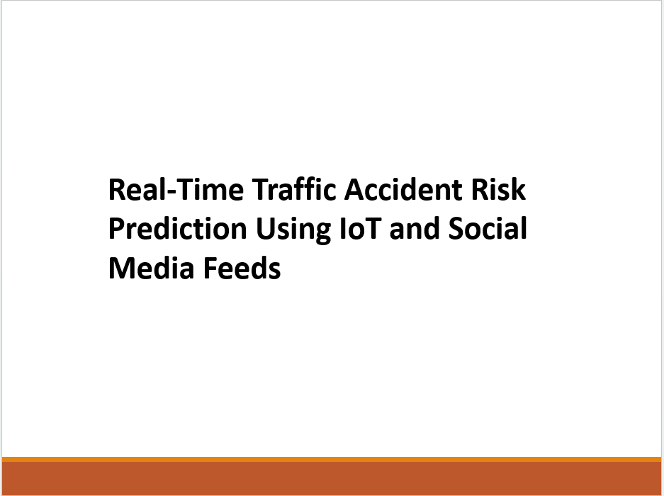

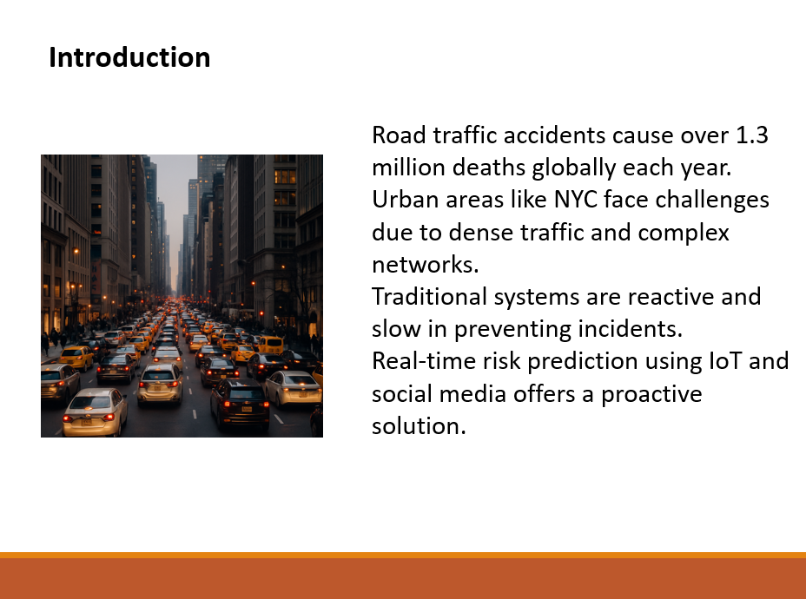

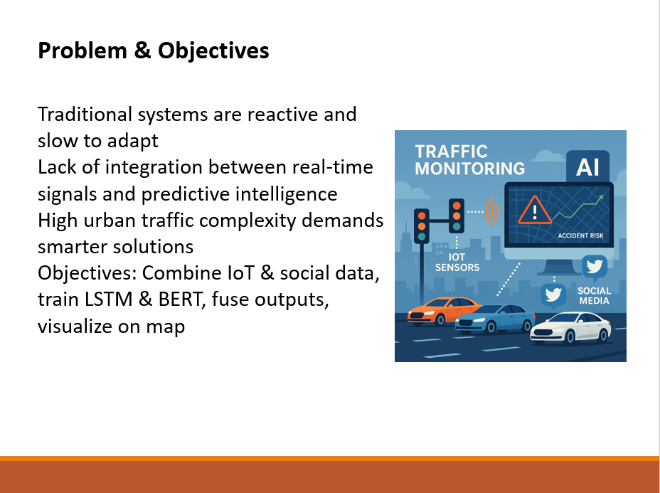

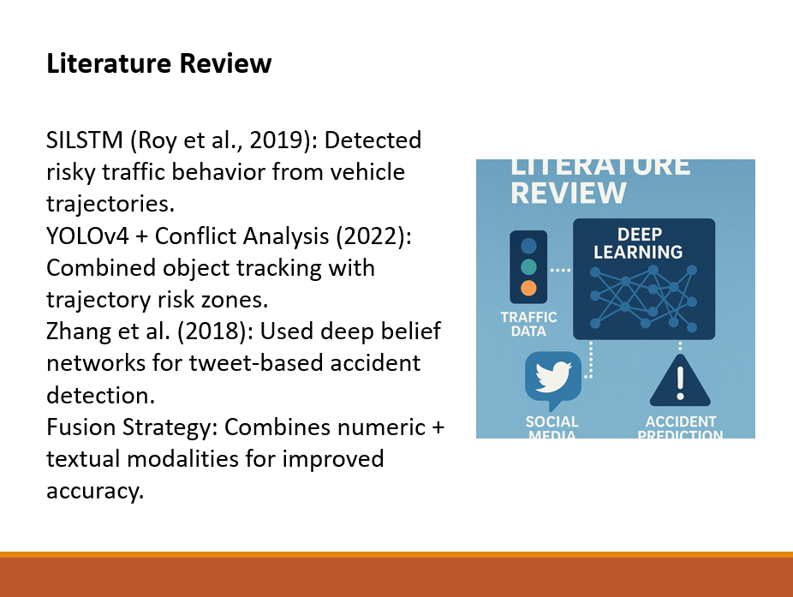

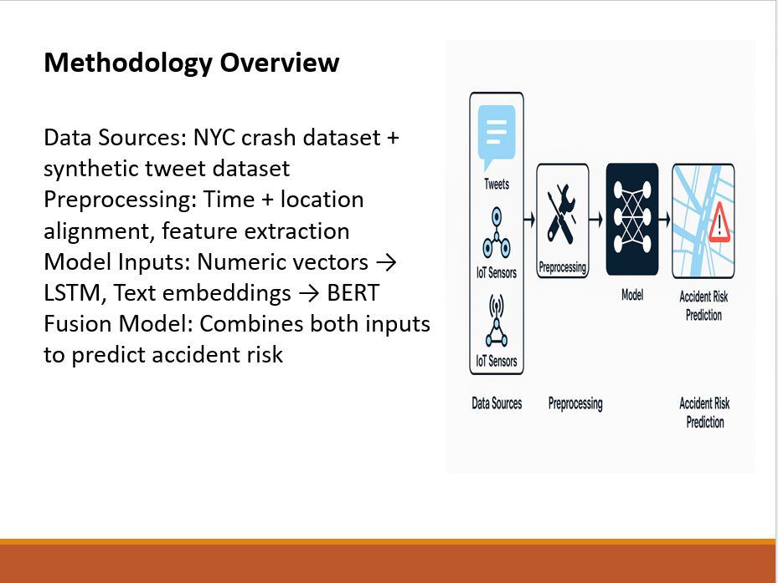

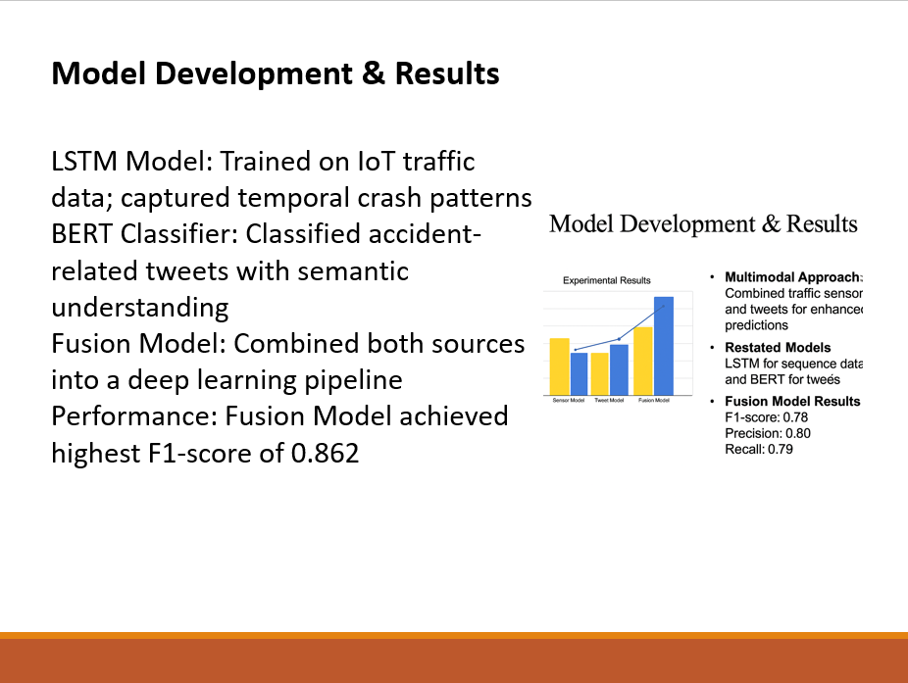

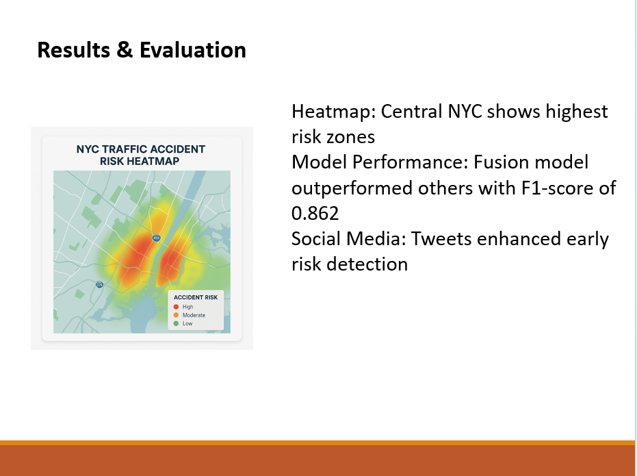

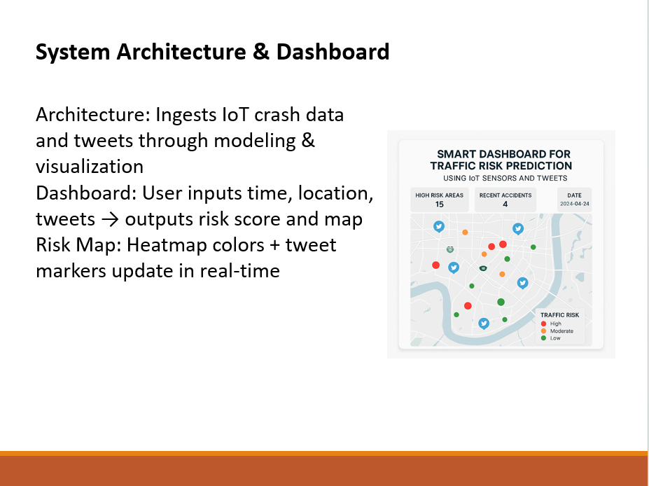

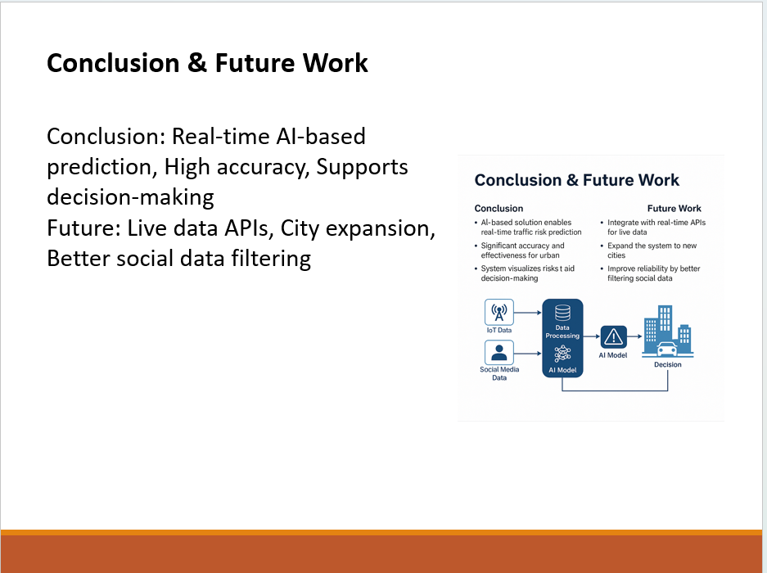



# Appendix—4 Project Proposal

Real-Time Traffic Accident Risk Prediction Using IoT and Social Media Feeds

### Introduction:

Traffic accidents continue to be one of the leading causes of deaths and injuries globally imposing major pressures on urban mobility, public safety and emergency medical services. The World Health Organization (WHO) estimates 1.3 million people are killed annually in road traffic crashes; many millions more are injured. Classical accident forecasting and traffic control methods generally use historical data (static in nature), and cannot adequately handle the complexity of the dynamic traffic environment in urban regions.

With the emergence of the Internet of Things (IoT) and the explosion of social networks, there is a new window of opportunity to tap into continuous data streams for more intelligent, adaptive traffic safety. Traffic sensors, embedded with IoT, scatter over cities, always tracking car speed, road density, and weather through data acquisition. Meanwhile social media platforms such as Twitter can also offer crowdsourced, up-to-the-minute information about accidents, traffic jams and icy road conditions. When these heterogeneous sources are combined, we can build a predictive system that detect accident prone zones before they occur.

This study aims to develop a real-time traffic accident risk prediction system in which IoT traffic sensor data and social media feeds are used dynamically to identify and predict the high-risk zones. The system will be built on a multi-modal deep learning model with LSTM on time-series analysis from IoT data and BERT on NLP analysis from social media text. A fusion model will combine knowledge from data collected from the two sources, yielding accurate and timely predictions of accident-prone areas. The resulting information will be displayed on an interactive map dashboard providing actionable inputs to city traffic authorities for OdR, traffic flow optimization and emergency response in a timely manner.

This approach overcomes the restrictions of current disaster prediction systems by utilizing a real-time assembled and multi-sourced data and advanced AI methods. It can greatly improve urban traffic safety and reduce the social and economic burden of traffic accidents.

### Problem Statement:

Road traffic crashes remain a major global problem, with more than 1.3 million people killed each year and serious economic and social consequences. Current traffic management systems are reactive and rely on real-time, static, and historical information, or incident reporting delays. However, these systems lack a mechanism to sense newly appearing accident hotspots so that they are not responsive to dynamic urban environments. With the wide proliferation of IoT based traffic sensors and the rising popularity of social media platforms where people share posts about accidents and the prevailing road condition, there lies this unexplored potential to exploit these data streams for proactive risk predictions. But the integration of heterogeneous data types - structured time-series sensor-based data, and unstructured textual-based social media -comprises technical problems that have not been totally solved so far.

### Aim and Objectives:

The goal of this project is to build a real-time traffic accident risk prediction system based on the multi-modal data collected from the IoT traffic sensors and social media feed.

The objectives are:

* To gather and pre-process real-time traffic sensor data from the IoT, such as speed, flow, density, weather, as well as social media posting (Twitter and other sources) related to accidents.
* Constructing an LSTM model for traffic sensor data for Temporal pattern analysis.
* To adapt a BERT-based NLP model for accident-related information extraction from unstructured tweets.
* To construct a fusion model by combining the knowledge of both modalities for the determination of accident risk levels.
* In order to facilitate traffic department in dynamic situation and emergency on the fly we need to implement a real-time visualization dashboard depicting high-risk region.

### Approach:

The system will be based on a stream processing data pipeline, in which the data feeds from the IoT sensors and real-time tweets are ingested via Apache Kafka and processed through Apache Spark Streaming. Preprocessing describes cleaning, normalization, geocoding and feature engineering of IoT data and natural language preprocessing and location extraction of tweets. There will be two parallel model architectures: an LSTM model working on the time series model of sensor data from IoT and BERT model addressing NLP model of social media. The single risk scores of all models will be combined at the end in a neural network to result in an aggregated risk score per road segment. A (non-technical but beautiful) dashboard (created with Gradio UI or dash) will display those predictions on an interactive map.

Dataset link: <https://data.cityofnewyork.us/Public-Safety/Motor-Vehicle-Collisions-Crashes/h9gi-nx95/data_preview>

### Technologies Used:

* **Programming:** Python (pandas, scikit-learn, TensorFlow/Keras, Hugging Face Transformers)
* **Streaming:** Apache Kafka, Apache Spark Streaming
* **APIs:** HERE Traffic API / TomTom Traffic API for IoT data, Twitter API v2 for social media feeds
* **Visualization:** Plotly Dash / Gradio UI with Mapbox or Leaflet integration
* **Deployment:** Docker, AWS EC2 (for real-time scalability)

### Legal, Social, Ethical, and Professional Considerations:

Privacy: The social media data is made anonymous, and no tweets that are not publicly visible are taken into account. User confidential information will be observed in accordance with Twitter Developer Policy and GDPR.

Bias & Fairness: The model can encode geographic or demographic biases in training data (e.g., urban areas with increased Twitter usage). Careful attention will be given to the detection and correction of such biases.

Professionalism: Development will be in accordance with ACM Code of Ethics and BCS Code of Good Practice, to ensure transparent, accountable, responsible AI deployment.

Compliance: API (HERE, Twitter) will be used under their terms of service. There will be no scraping or access without permission.

### Background:

Prediction of traffic accidents is often made based on statistical method which utilizes the past traffic accidents. Although these methods provide valuable information, they are not suitable for instant risk assessment. Recent HW/SW advances in IoT and machine learning make it possible to design more complex systems that are able to exploit dynamic traffic and environmental data. In addition, on social media platforms, rapid reporting of incident is increasingly noticed. Integrating these technologies can open the door to system forecasting the risks in accident, which may in turn helps the city traffic and transportation department to respond to or prewarning the accident.

### Literature Review:

Risk prediction of traffic accidents by real-time data have been a hot-spot research field in the past years based on the developments of IoT, machine learning and NLP. Zhang et al. (2018) developed an LSTM-based deep learning model to analyse IoT sensor-based time-series traffic data for hotspot detection, with their model providing higher performance compared to conventional statistical techniques. Similarly, Chen et al. (2020) combined weather, road condition and traffic flow data for severity prediction of accidents, demonstrating the significance of multimodal data fusion. Social media, in particular Twitter, have shown to be an important information source about traffic. Wang et al. (2016) performed real-time traffic incident detection based on geotagged tweets, with an accuracy of over 85% by combining NLP and geospatial analysis. More recently, Huang et al. (2022) employed BERT-based models to categorize tweets related to traffic and demonstrated the dominance of deep NLP models for deriving actionable insights from noisy social media data as compared to traditional methods.

Integration techniques of IoT and social media data have also been studied. Li et al. (2021) modulated the temporal dependence of the attention with a multi-modal functions attention mechanism and observed that the performance was improved in the processing and predicting in the dynamic urban environment. Looking from a system angle, the work of Liu et al. (2019) also created a tailored traffic monitoring system based on Apache Kafka and Spark Streaming, showing that is possible to develop low-latency pipelines to process and ingest live-streaming data. The visualization of predicted risk zones is also an important ingredient. Zhou et al. (2021) created a dashboard on Plotly and Mapbox APIs for traffic departments of cities to act proactively.

However, current research has limitations in availability of data, real-time processing, and generalization over unseen locations. Such studies are rare even when high-frequency Iot data was combined with unstructured text from social media at scale. Furthermore, the ethical and legal implications related to data privacy on user-generated data, which most technical solutions have not deeply explored. To overcome these gaps, in our current research we propose to develop a real-time multimedia prediction system by fusing live IoT traffic data and social media feeds based on the fusion of LSTM in time-series and BERT in the textual data for the global epidemic spread predictions.

### Key Model Assumptions:

The model takes IoT traffic sensors (speed, density, weather) and tweets as the input and it considers that the data for both is updated, accurate and is a well representation of the real-world. It assumes that the geotagged tweets are good sources for incident location, and the historical data can present patterns which are suitable within the current time. Also, it assumes that the APIs for gathering data are reliable and produce good quality streams.

### Performance Metrics:

The effectiveness of the model will be validated with various evaluation metrics, including accuracy, precision, recall, and F1-score for accident prediction and RMSE for continuous risk score. In time-series prediction with LSTM, MAE (Mean Absolute Error) and R² (coefficient of determination) are used for metrics. The real-time execution will also be conducted and evaluated in terms of latency and throughput of the streaming pipeline.

### Data Management:

Strong data handling best practices will be used such as secure API access, anonymisation of sensitive data (particularly social media), and adherence to GDPR and other privacy-related legislation. The data will be persisted in some sort of structured data store, such as MongoDB or PostgreSQL so that queries can be executed fast. Datasets will be version controlled and log mechanisms will facilitate tracking and auditability of all data flows in the system.

### Conclusion:

This work will develop a real time traffic accident risk prediction system by integrating IoT sensor data with public social media news feeds, using state of the art deep learning models such as LSTM and BERT. Risk visualizations Summary: Providing dynamic risk visualizations based on location to support smart city traffic management, improving road safety and driving proactive decision-making. The solution makes use of multi-modal data, factors in considerations of ethical and legal responsibility and determines the potential impact in the real world. It fills a demand for urban mobility intelligence and offers a stage from which broad application may be achieved.

### References:

* **Zhang et al., 2018**, *“A deep learning approach for detecting traffic accidents from social media data”*

They analysed 3 million tweets using LSTM/DBN to identify accident-related content with ~85 % accuracy.

<https://arxiv.org/abs/1801.01528>

* **Neruda & Winarko, 2021**, *“Traffic Event Detection from Twitter Using a Combination of CNN and BERT”*

Combined CNN and BERT to detect and locate traffic events in tweets.

DOI: 10.1109/ICACSIS53237.2021.9631334

* **Parsa et al., 2019**, *“Applying Deep Learning to Detect Traffic Accidents in Real Time Using Spatiotemporal Sequential Data”*

Employed LSTM and GRU with weather and traffic congestion data for accident detection (AUC ≈ 0.85)

* **Hybrid CNN‑LSTM Model for Traffic Accident Frequency Forecasting (2022)**  
  Applied CNN-LSTM to predict seasonal accident frequency in Antalya (2012–2017), outperforming ARIMA, Prophet, and single LSTM models.
* **Abdel‑Aty et al. (2024)** – Transformer‑based risk prediction methods in freeway environments  
  Showcased advanced transformer models for real-time crash risk prediction with improved sensitivity and accuracy.
* **Real-time crash risk prediction on arterials based on LSTM‑CNN (2019)**  
  Introduced a hybrid LSTM–CNN architecture that significantly improved real-time crash risk prediction on arterial roads.

# Appendix—5 Links

Dataset Link: <https://data.cityofnewyork.us/Public-Safety/Motor-Vehicle-Collisions-Crashes/h9gi-nx95/data_preview>

GitHub link: <https://github.com/Prathyushadodla>

OneDrive Link: [Dissertation-main](https://livecoventryac-my.sharepoint.com/:f:/g/personal/dodlap_uni_coventry_ac_uk/El9oM-9qQ-FApjEu8Wtqkn0B-meBm5zcU-bKvSOzvgXRUw?e=jwlzRb)